**Introduction To GIT -Basics**

Git is a distributed revision control and source code management system with an emphasis on speed. Git was initially designed and developed by Linus Torvalds for Linux kernel development.

Git is a free software distributed under the terms of the GNU General Public License version 2.

## **Version Control System**

**Version Control System (VCS)** is a software that helps software developers to work together and maintain a complete history of their work.

Listed below are the functions of a VCS −

* Allows developers to work simultaneously.
* Does not allow overwriting each other’s changes.
* Maintains a history of every version.

Following are the types of VCS −

* *Centralized version control system (CVCS).*Centralized version control system (CVCS) uses a central server to store all files and enables team collaboration. But the major drawback of CVCS is its single point of failure, i.e., failure of the central server.
* *Distributed/Decentralized version control system (DVCS)*DVCS clients not only check out the latest snapshot of the directory but they also fully mirror the repository. If the server goes down, then the repository from any client can be copied back to the server to restore it. Every checkout is a full backup of the repository.
* 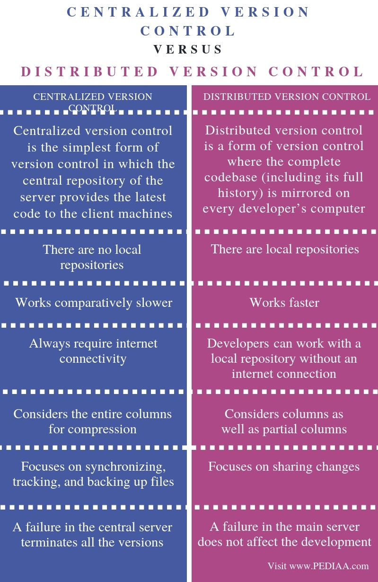

**Repositories:**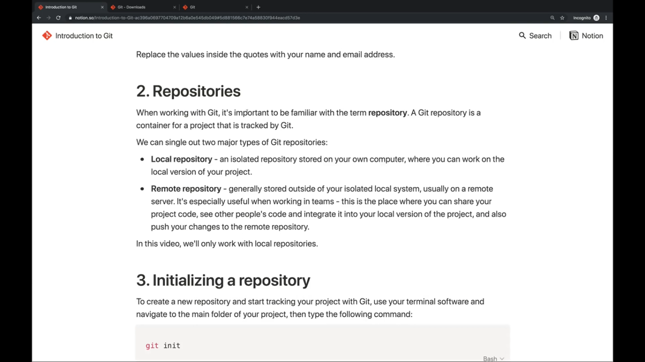

## **Advantages of Git:**

### Free and open source

### Fast and small

### Implicit backup

### Security

### No need of powerful hardware

### Easier branching

## **DVCS Terminologies:**

### **Local Repository:** provides the user with a private workspace.Git takes it one step further by providing them a private copy of the whole repository. Users can perform many operations with this repository such as add file, remove file, rename file, move file, commit changes, and many more.

### **Working Directory and Staging Area or Index**:

### The working directory is the place where files are checked out.Git doesn’t track each and every modified file. Whenever you do commit an operation, Git looks for the files present in the staging area. Only those files present in the staging area are considered for commit and not all the modified files.

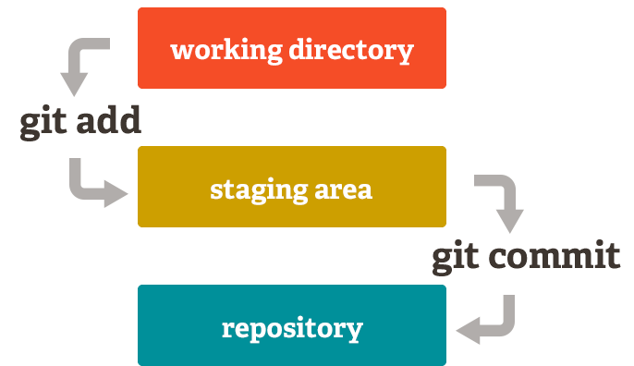

### **Blobs**

Blob stands for **B**inary **L**arge **Ob**ject. Each version of a file is represented by blob. A blob holds the file data but doesn’t contain any metadata about the file. It is a binary file, and in Git database, it is named as SHA1 hash of that file. In Git, files are not addressed by names. Everything is content-addressed.

### **Trees**

Tree is an object, which represents a directory. It holds blobs as well as other sub-directories. A tree is a binary file that stores references to blobs and trees which are also named as **SHA1** hash of the tree object.

### **Commits**

Commit holds the current state of the repository. A commit is also named by **SHA1** hash. You can consider a commit object as a node of the linked list. Every commit object has a pointer to the parent commit object. From a given commit, you can traverse back by looking at the parent pointer to view the history of the commit. If a commit has multiple parent commits, then that particular commit has been created by merging two branches.

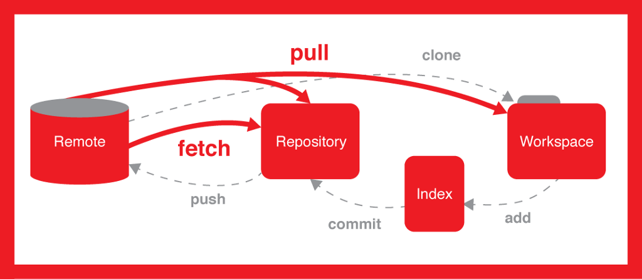

### **Branches**

Branches are used to create another line of development. By default, Git has a master branch, which is same as trunk in Subversion. Usually, a branch is created to work on a new feature. Once the feature is completed, it is merged back with the master branch and we delete the branch. Every branch is referenced by HEAD, which points to the latest commit in the branch. Whenever you make a commit, HEAD is updated with the latest commit.

### **Tags**

Tag assigns a meaningful name with a specific version in the repository. Tags are very similar to branches, but the difference is that tags are immutable. It means, tag is a branch, which nobody intends to modify. Once a tag is created for a particular commit, even if you create a new commit, it will not be updated. Usually, developers create tags for product releases.

### **Clone**

Clone operation creates the instance of the repository. Clone operation not only checks out the working copy, but it also mirrors the complete repository. Users can perform many operations with this local repository. The only time networking gets involved is when the repository instances are being synchronized.

### 

### **Pull**

Pull operation copies the changes from a remote repository instance to a local one. The pull operation is used for synchronization between two repository instances. This is same as the update operation in Subversion.

### **Push**

Push operation copies changes from a local repository instance to a remote one. This is used to store the changes permanently into the Git repository. This is same as the commit operation in Subversion.

### 

***Basic Workflow of GIT:***Let us see the basic workflow of Git.

Step 1 − You modify a file from the working directory.

Step 2 − You add these files to the staging area.

Step 3 − You perform commit operation that moves the files from the staging area. After push operation, it stores the changes permanently to the Git repository.

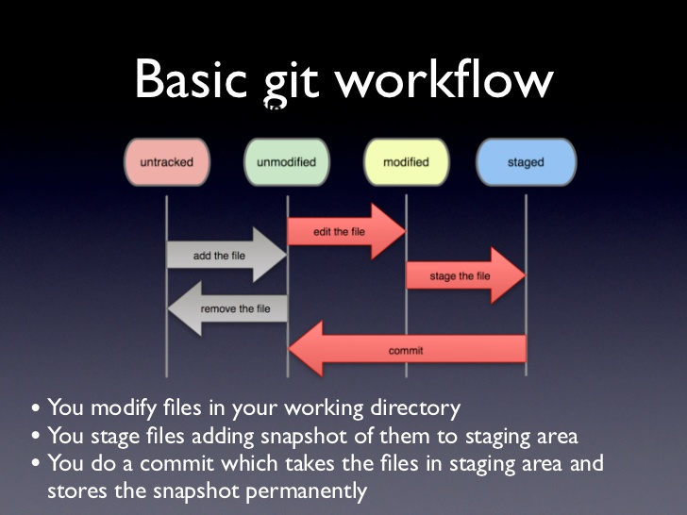

*Reference link:*

<https://www.tutorialspoint.com/git/git_basic_concepts.htm>

**GETTING STARTED WITH GIT*(basic workflow of GIT)***

1. **Installing git:** Install Git using the command sudo apt install git or yum install git. If git is already installed try checking it by git --version .

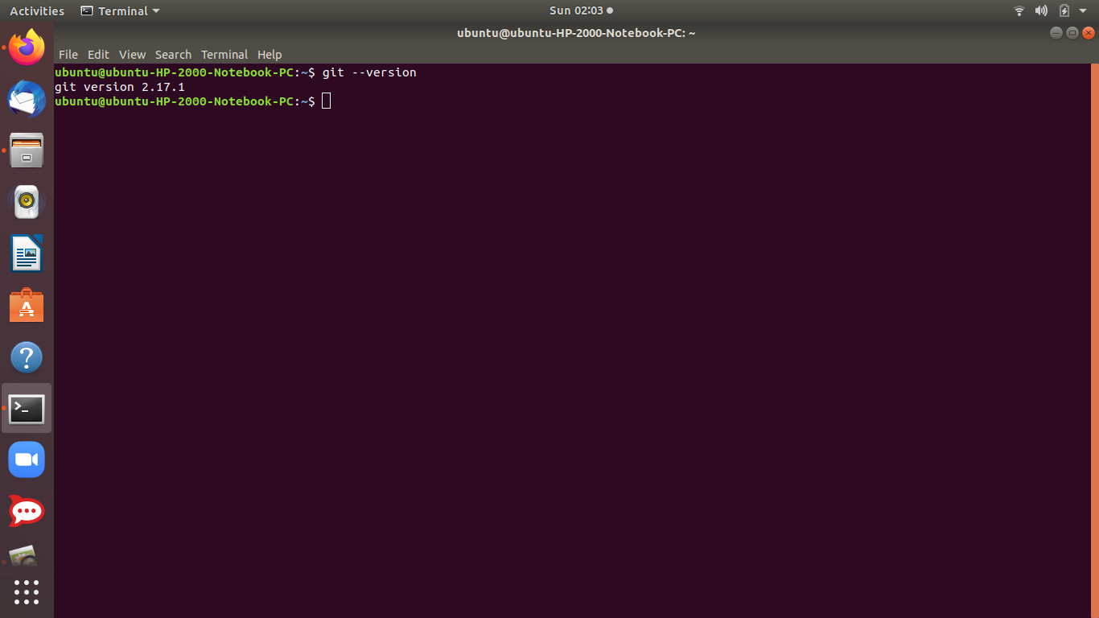

**2)Configuring your name and email to identify yourself:**using the git config command.

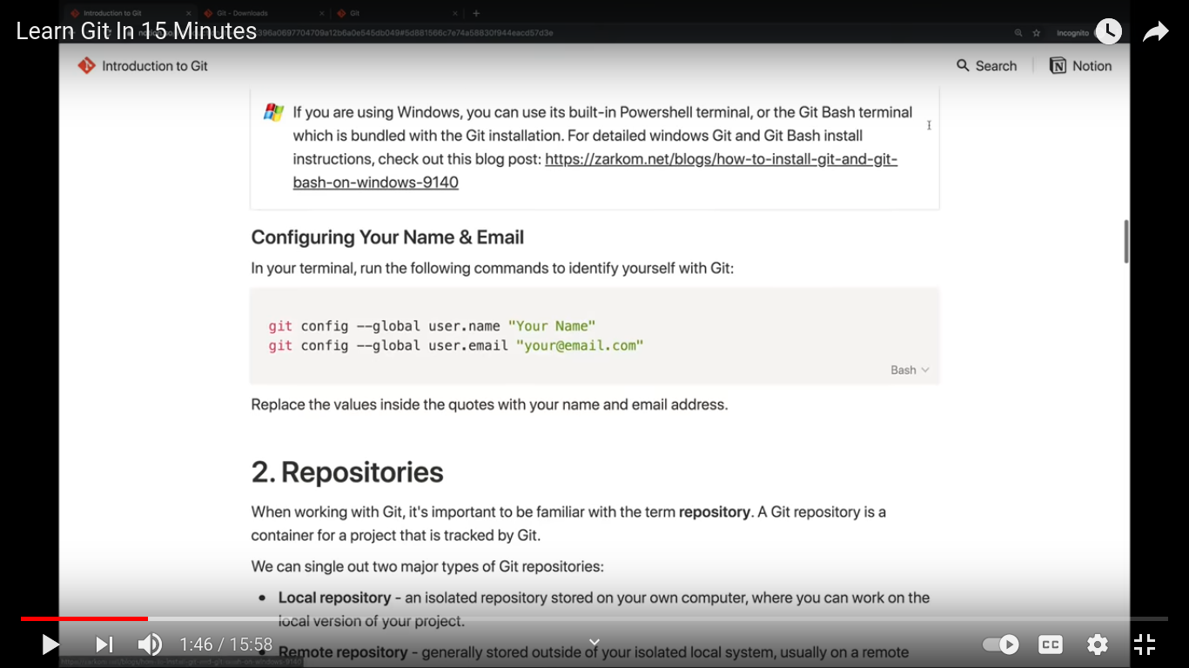The --global flag helps git to read and write our files in our git repositories and states this value for all our git repositories.We can also set different values for different repositories.

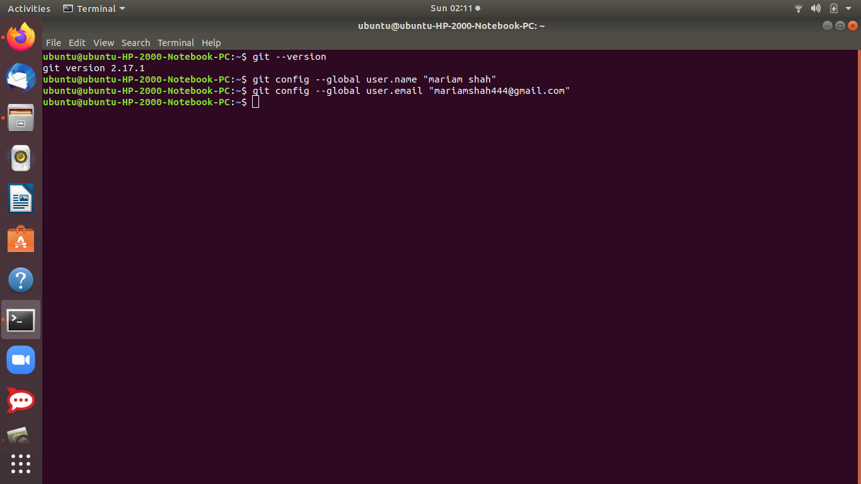

**3)Working with a Git Repository:** All our work gets stored in a repository.So, its important to either create/ initialise a new repository for our committed work or copy the image of another repository and start working on it. There are 2 ways in which either of the 2 can be done :

1. **$ git init :** creates a new repository.
2. **$ git clone :** makes a copy of a repository which already exists somewhere.

We create a new directory ‘project’ and then, after running **git init** command ,it initializes an empty git repository in the current directory. It shows a new **.git** directory made inside our home directory project.

* **ls -la** command gives a list of all hidden files including our .git file.This file tracks all changes made to **files** in your project, building a history over time.
* **ls -l .git/** gives a list of all files including config,branches, description,HEAD,objects,info etc..git is initialized by git init.

**.git** contains all information required for version control. If you want to clone your repo, copy .git is enough.

**4 sub-directories:**

* hooks/ : example scripts
* info/ : exclude file for ignored patterns
* objects/ : all "objects"
* refs/ : pointers to commit objects

**4 files:**

* HEAD : current branch
* config : configuration options
* description
* index : staging area

**Here "object" includes:**

* blobs(files)
* trees(directories)
* commits(reference to a tree, parent commit, etc)
* This whole is called the **git directory** and the area outside the git directory is called the working tree.
* The **working tree**, or working directory, consists of files that you are currently working on. You can think of a working tree as a file system where you can view and modify files.

*The git directory acts as a complete database of files and folders while as working tree /directory is the place where we perform different operations on our file like editing,adds,remove and change its versions before pushing the final changes to the git repository.*

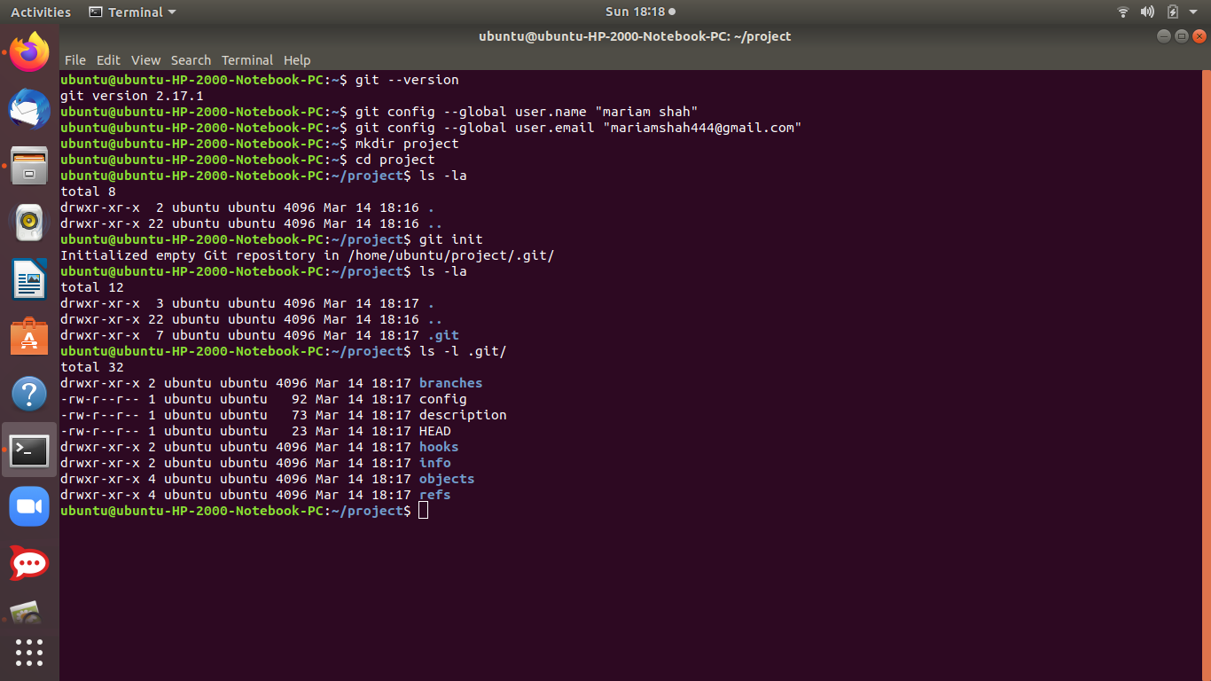

This returns an empty working tree.

**4)Checking the status:**while located inside the project folder in our terminal ,we can type the following command to check the status of our repository.

$ git status

It shows us which files are changed, and which files have been tracked etc.

Right now since our working tree is empty, it will show no commits yet and to create and copy files begin with git add command.

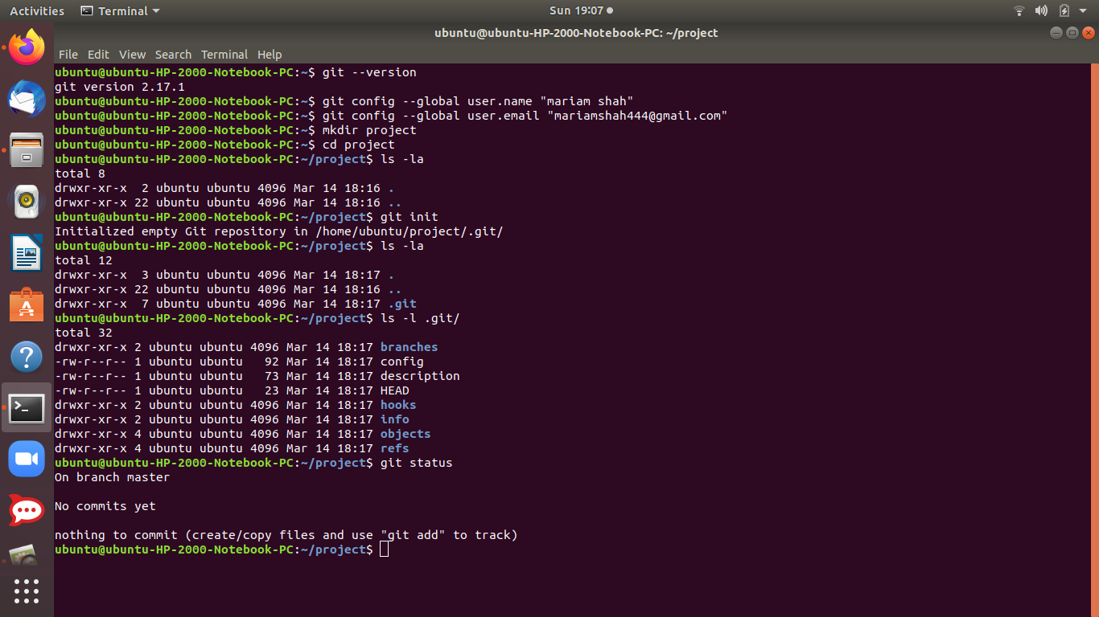

**4) Staging the files:** From the project folder, we can use the git add command to add files to the staging area which allows them to be tracked.

We can add specific files to the staging area by running the following command:

$ git add file.py *(name of file)*

To add multiple files, we write

$ git add file1.py file2.py file3.py *(name of the files)*

To check if the files are added in the working directory we run the check status command , and the file is tracked.

We are going to copy an already created file python.py in home to the current directory and then adding the file using the git add command, the file is added to the staging area and becomes a tracked file.

* *If we had ran the command git status before adding the file into git directory, it would have shown us the file as untracked.*

**5) Making Commits:** A commit is a snapshot of our code at a particular time, which we are saving to the commit history of our repository.After adding all the files which we want to track to the staging area using the **g**it addcommand, we are ready to make a commit.

To commit the files from the staging area, we use the following command:

$ git commit -m “commit message”

Inside the quotes we should write a commit message which should be a descriptive summary of the changes you are committing to the repository.

* We can also type a new command, git log which is going to give us the history of our commits to this file

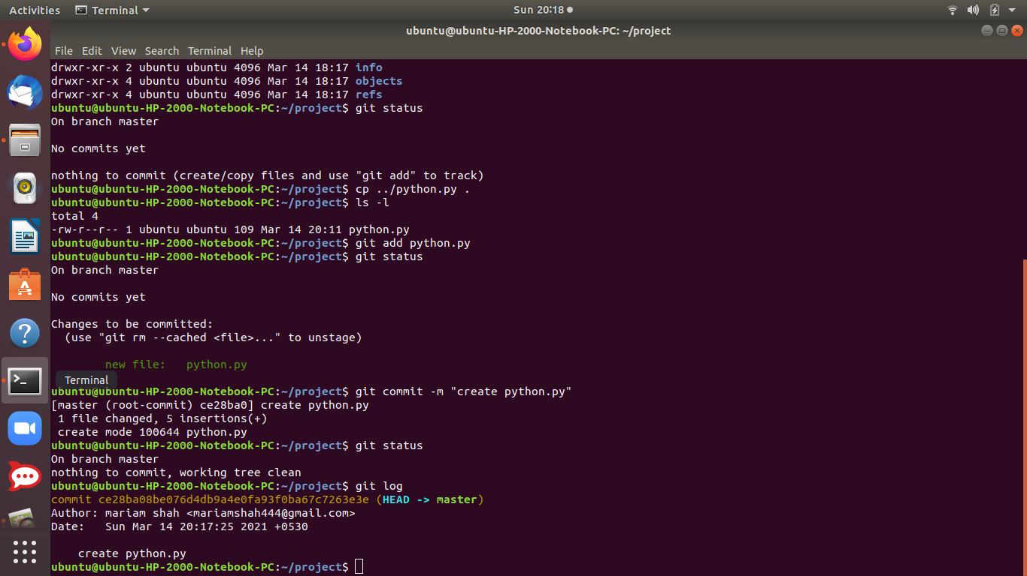

* **Tracked and untracked files:**
* Tracked files are files that were in the last snapshot; they can be unmodified, modified, or staged. In short, tracked files are files that Git knows about.They have been already added to git directory using the git add command.
* Untracked files are everything else — any files in your working directory that were not in your last snapshot and are not in your staging area.

As an example I have created another file mean.py in the project directory which has not yet been added to the staging area, hence displays untracked.And after running git add mean.py it is placed in staging area for editing etc.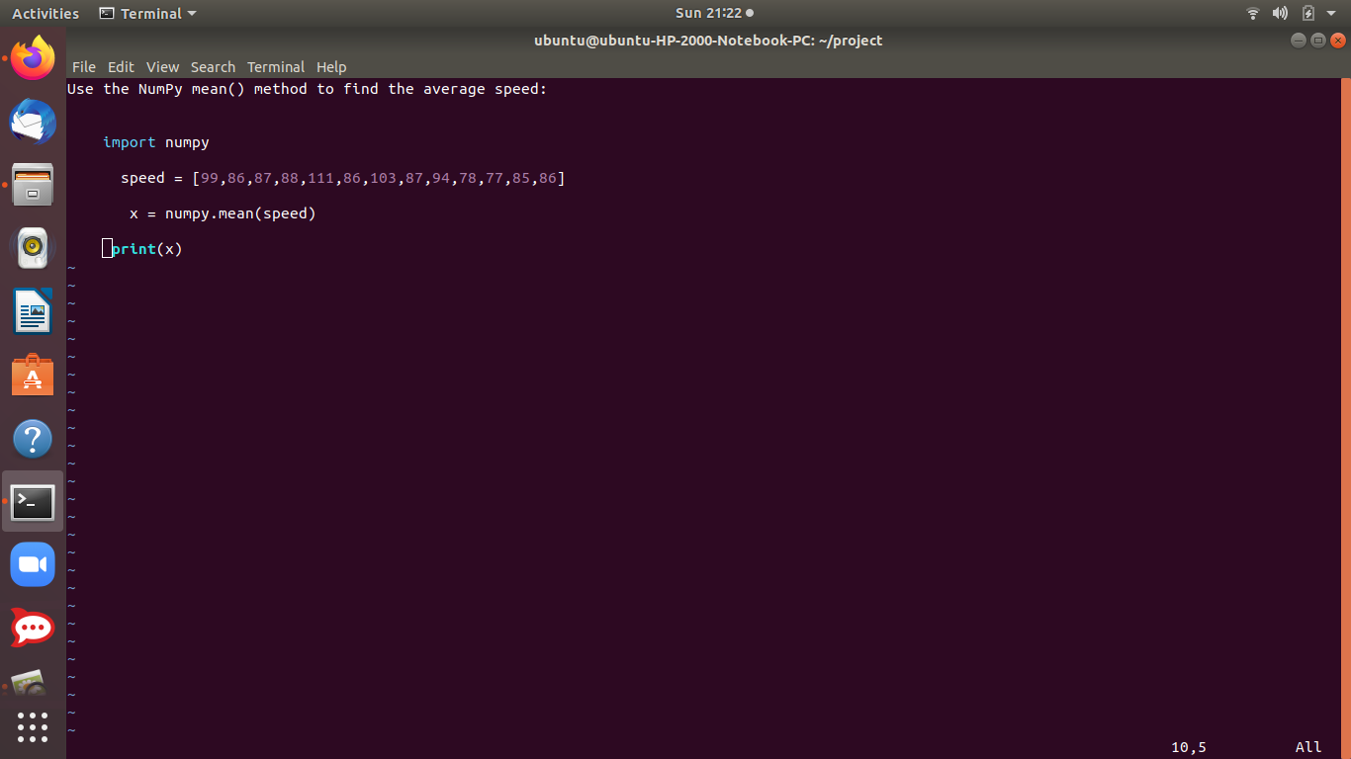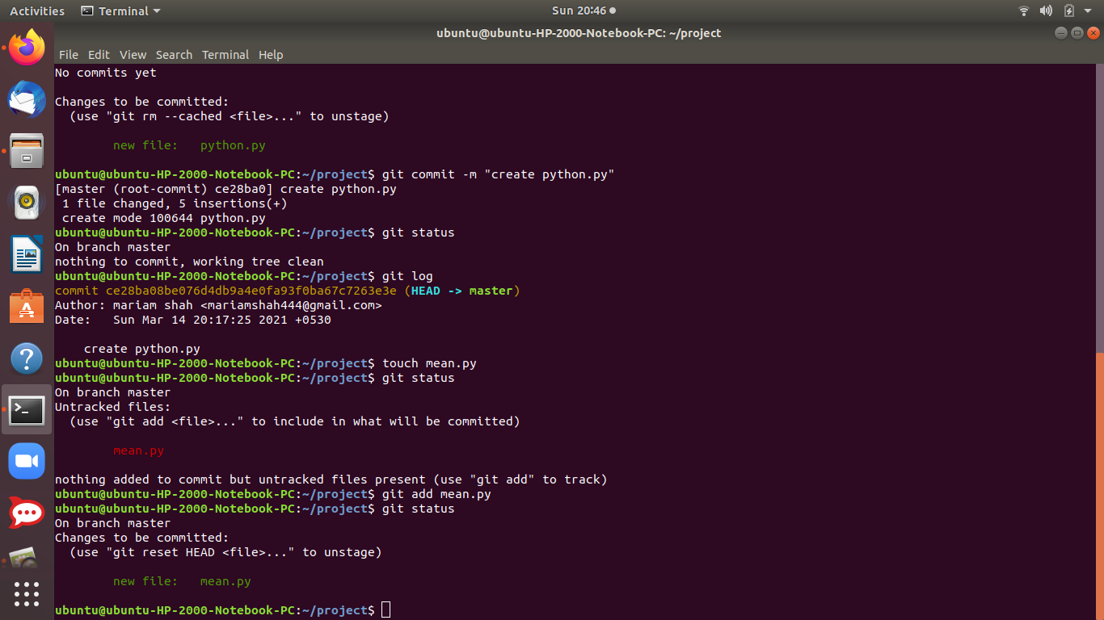

## 

## 

## Reference links:

<https://www.youtube.com/watch?v=USjZcfj8yxE>

<https://www.notion.so/Introduction-to-Git-ac396a0697704709a12b6a0e545db049>

**More on GIT: Commit history,undo , checkouts and Branches**

We know every time we want to write changes onto our files in the working tree ,we need to add the files to the staging area and then commit the changes.We already know to see all the commits that were made for our project, we can use the following command $ git log .

As an example, we already have mean.py and python.py added to the working tree, so we are bringing small changes to python.py and then adding them to staging area to modify and finally commit the changes.And all long checking the status and log whether the changes have been made.

We’d see, that every time a run the git log command,there is a commit hash associated with each commit change in history.This commit **hash** can be used to go back to our commits.

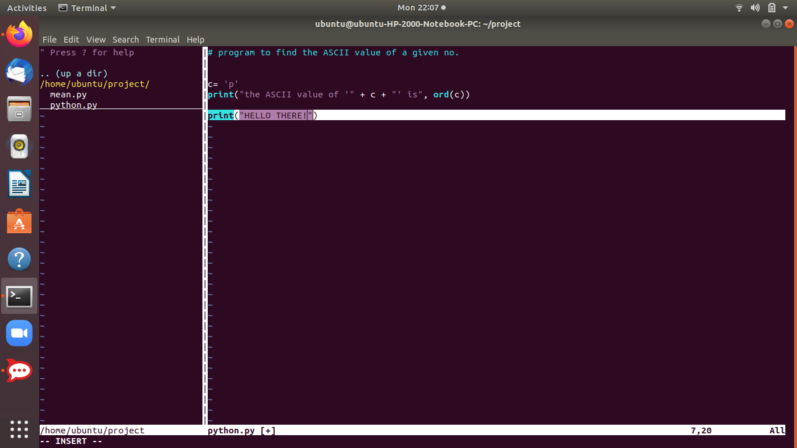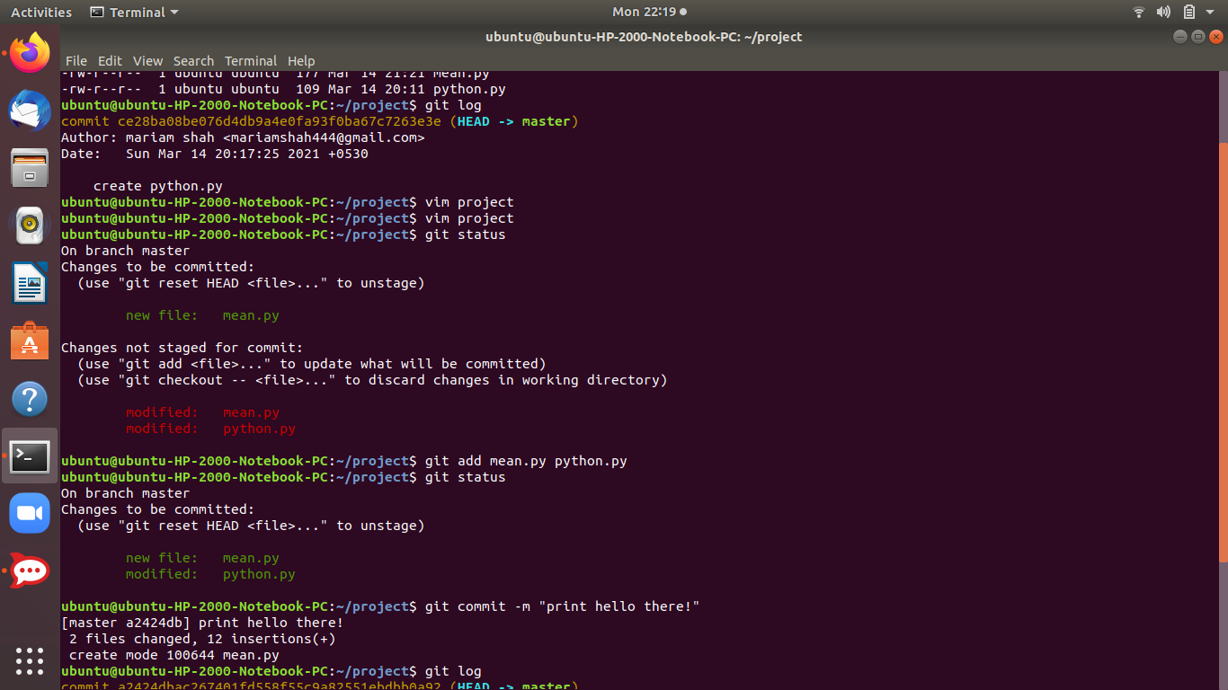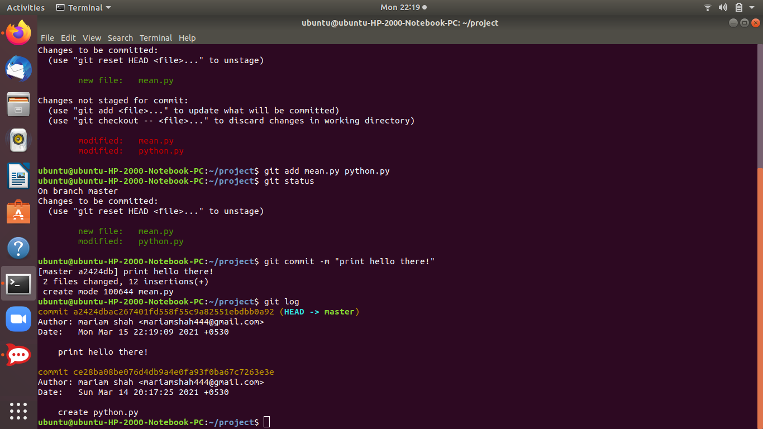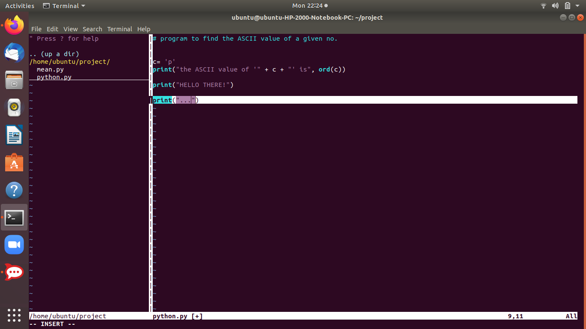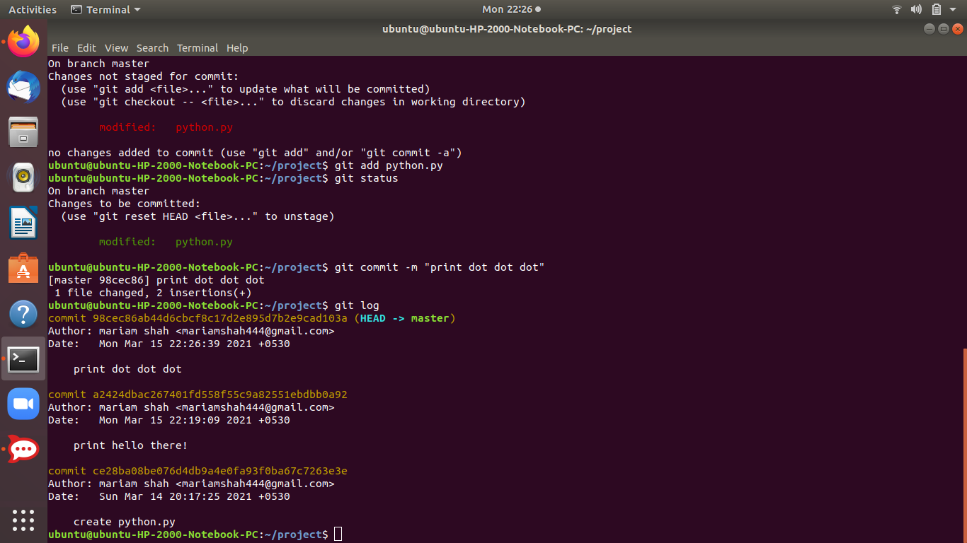

**Checkout command:**  To go back to a previous state of your project code that you committed, you can use the following command:

$ git checkout <commit-hash>

Replace <commit-hash> with the actual hash for the specific commit that you want to visit, which is listed with the git log command.

Here we would go back to the previous commit that printed the message “HELLO THERE!”.When we do so, we see that in our vim editor the python.py file where is brought changes no longer shows the print “...” line of code that was present in the previous commit.

* *This checkout command is like a time machine. We can go back in the history of our previous commits any time .*

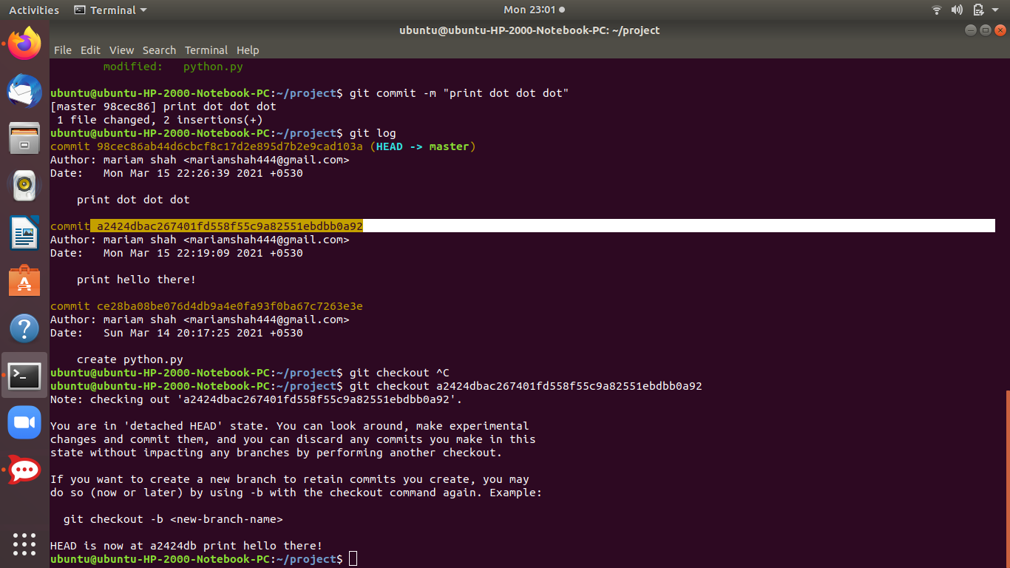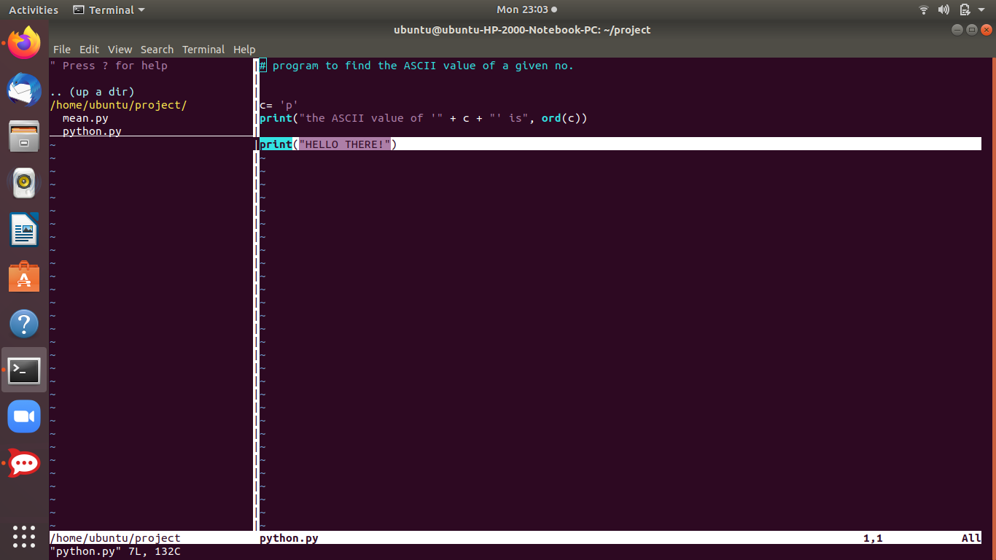

## 

## 

## **Ignoring files**

To ignore files that you don't want to be tracked or added to the staging area, you can create a file called .gitignore in your main project folder.

Inside of that file, you can list all the file and folder names that you definitely do not want to track (each ignored file and folder should go to a new line inside the **.gitignore** file).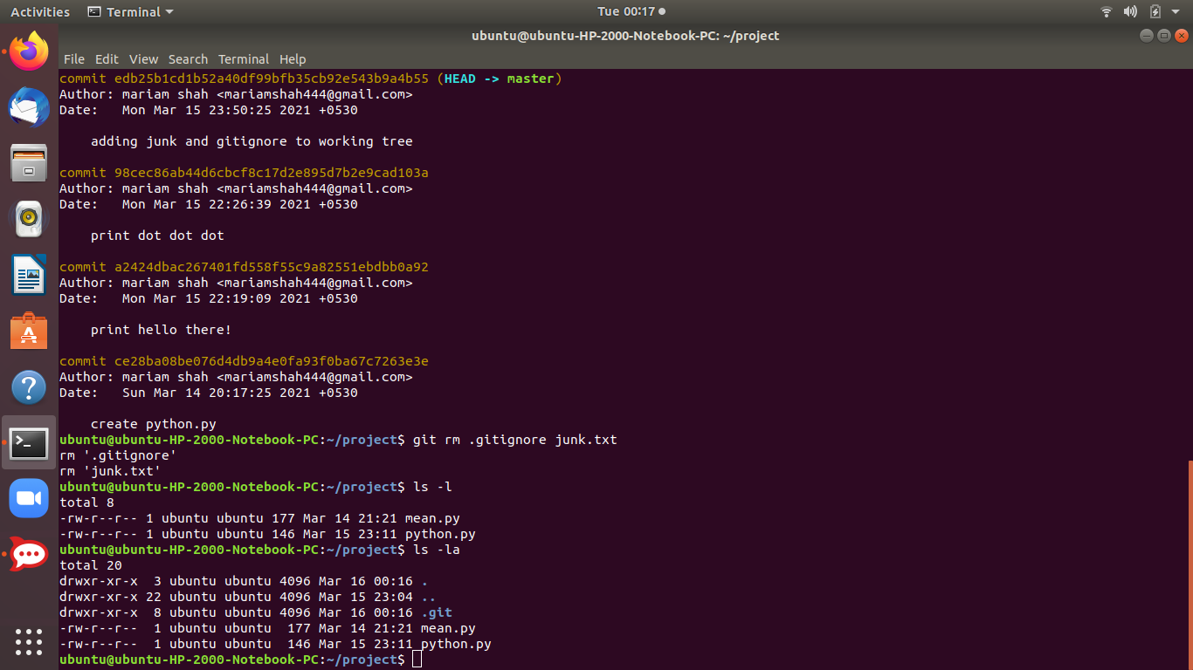

## **Undo Last Git Commit with reset:**

The easiest way to undo the last Git commit is to execute the “git reset” command with the “–soft” option that will preserve changes done to your files. You have to specify the commit to undo which is “HEAD~1” in this case.

The last commit will be removed from our Git history.

$ git reset --soft HEAD~1

If you are not familiar with this notation, “HEAD~1” means that you want to reset the HEAD (the last commit) to one commit before in the log history.

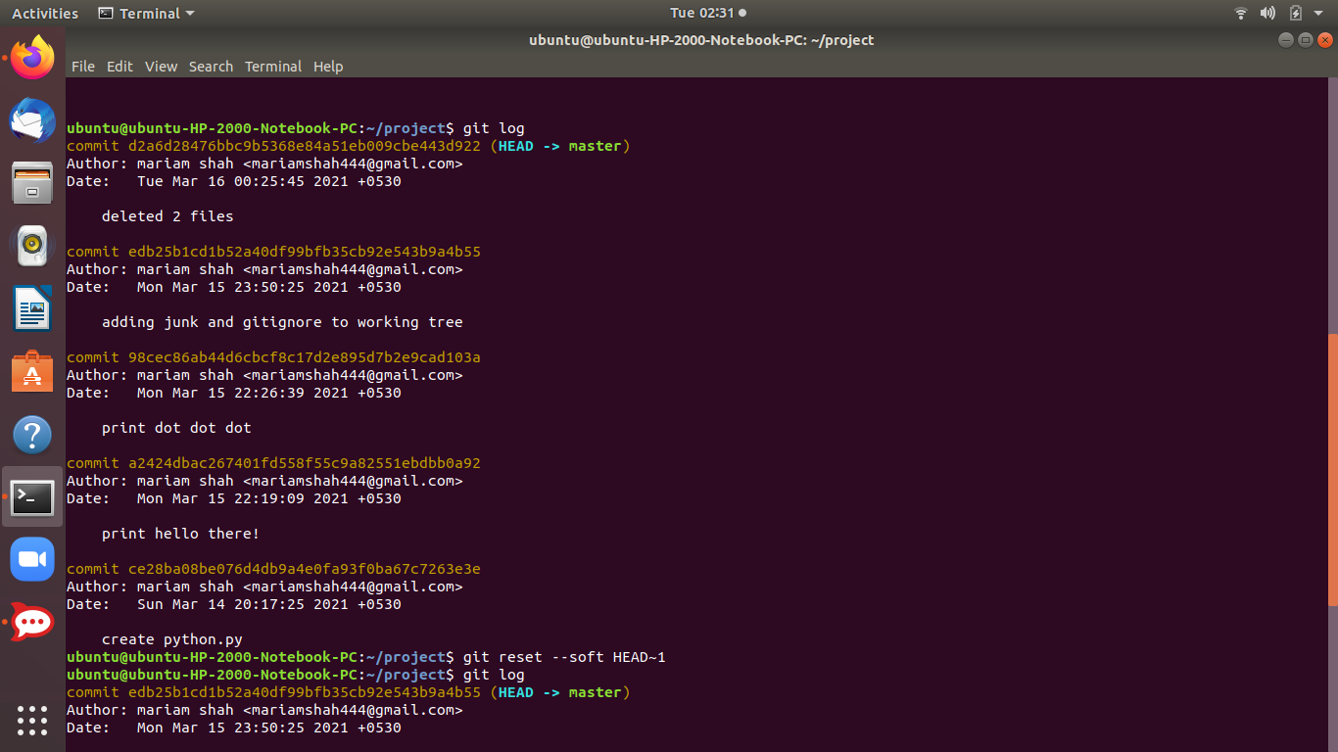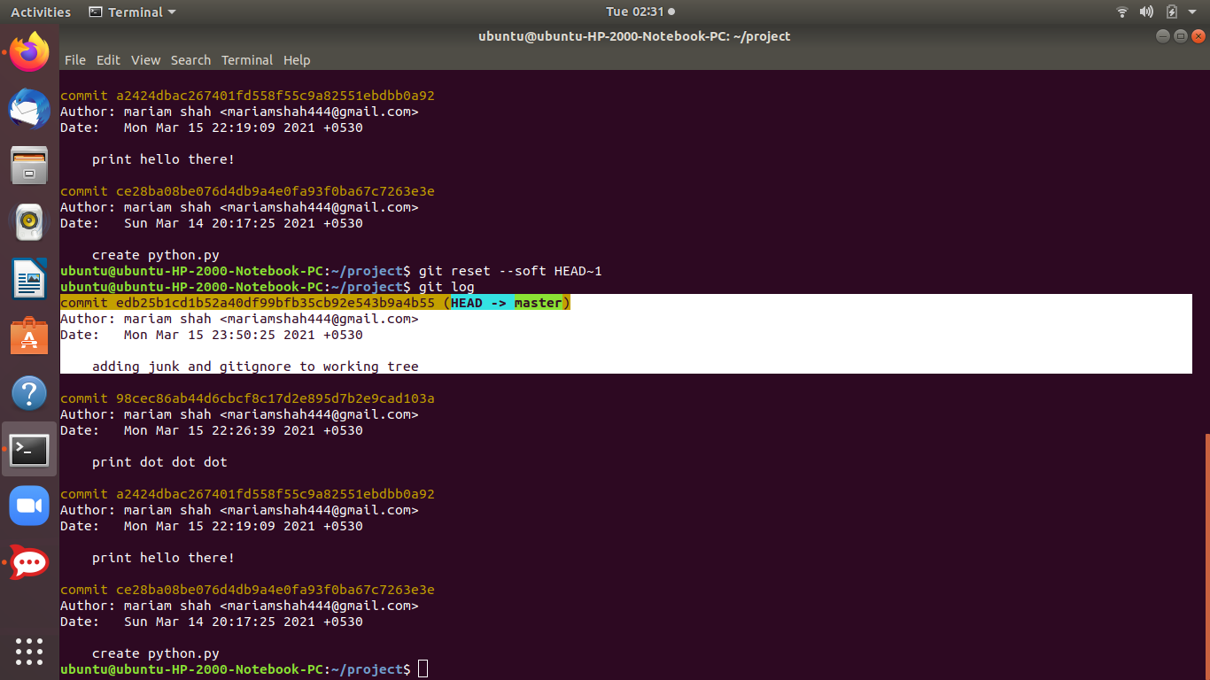

*We can see,the head is holding next commit-hash and has undone previous commit with message ‘deleted 2 files’*

## **Branch:**

The main standard branch that is created by default is called MASTER

A **branch** could be interpreted as an individual timeline of our project commits.

With Git, we can create many of these alternative environments (i.e. we can create different **branches**) so other versions of our project code can exist and be tracked in parallel.

That allows us to add new (experimental, unfinished, and potentially buggy) features in separate branches, without touching the master branch

When we initialize a repository and start making commits, they are saved to the **master** branch by default.

**1) List the branches in the project:** If our head is not on any other branch, this command will return the master branch.

$ git branch

$ git checkout master *if we are on a different branch to*

*checkout to master branch*

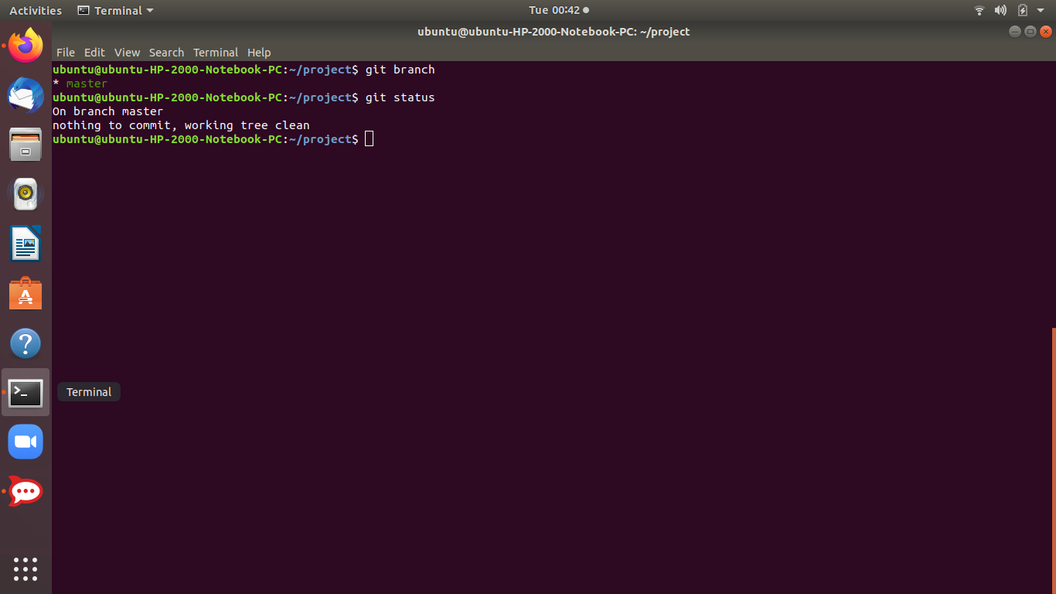

**2) Create a new branch:**You can create a new branch using the following command:

git branch <new-branch-name>

The new branch that gets created will be the reference to the current state of your repository.

## **Changing branches**

To switch to a different branch, you use the **git checkout** command:

git checkout <branch-name>

***USE:****Usually when we are working on additional features of the project, before being sure to add them to the actual project timeline we put them in a new branch till we are approved.*

Here, just for the sake of understanding workflow we will create a new branch named “my branch” and then we can checkout to this new branch by using the checkout command.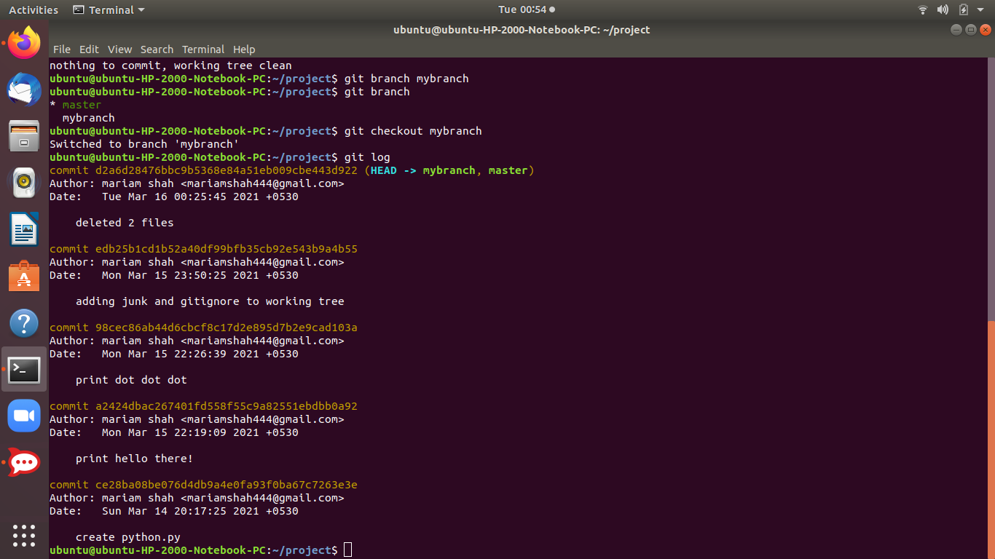

*Now, here till now the new branch ,mybranch is on the same progress as the master branch, but now if we modify and commit new changes (additions etc) to the files in our project , it will not be reflected to the master branch till I don’t merge master branch with the new branch.*

So, branches kind of create a new timelines for developers to add new things till they are get sure and approved of the new things they have tried.

Lets, modify the python.py file now with simple plain print lines of text since we are not yet working on any project and see;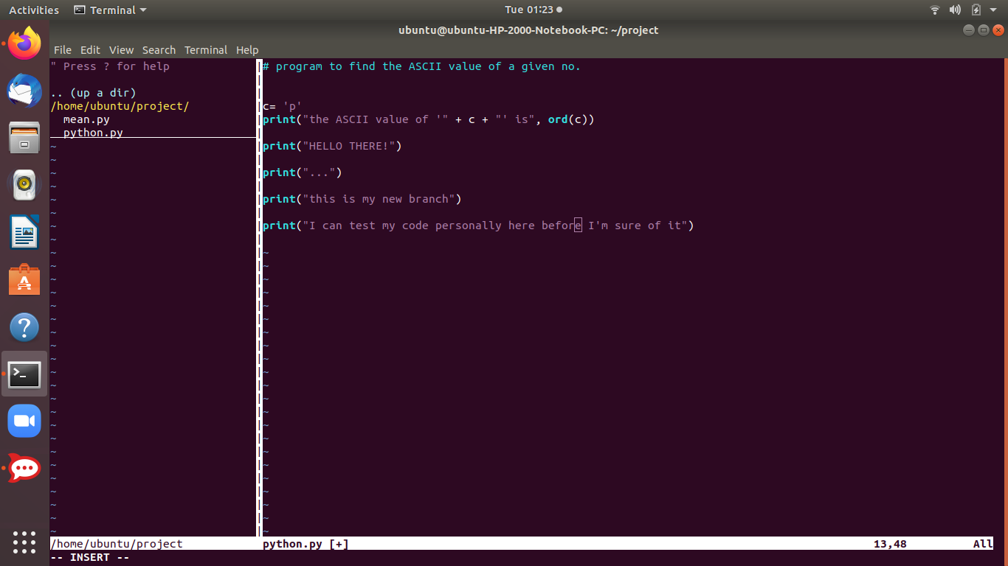

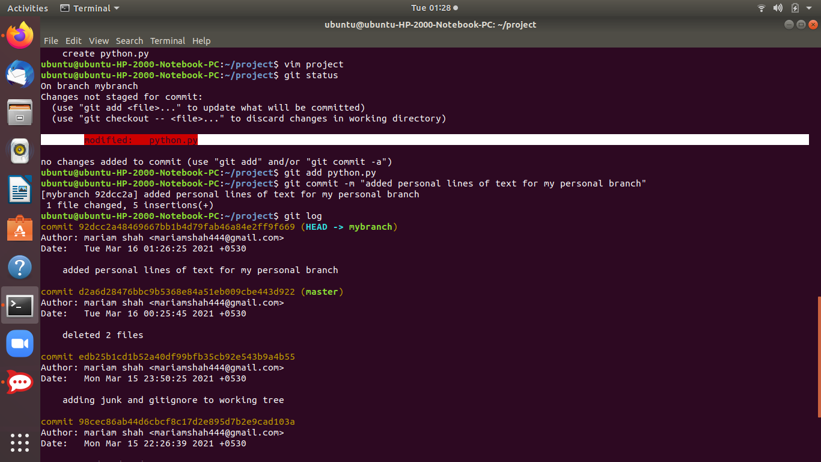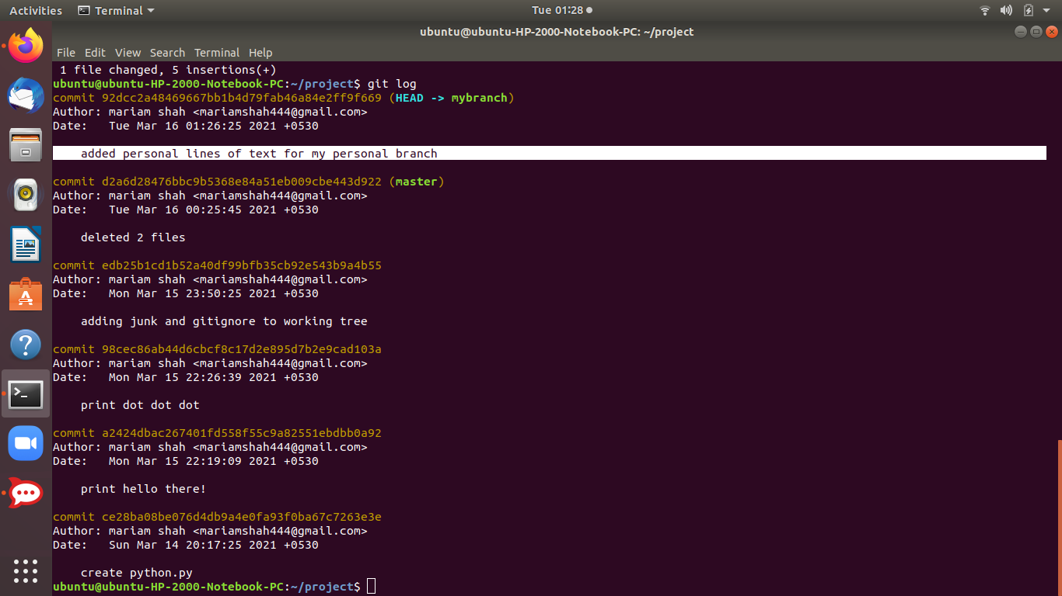

*Now, if we checkout to the master branch , we will see it doesn’t say us anything about the new lines of text we added to python.py log history since that is on our branch which we specified for personal code testing.*

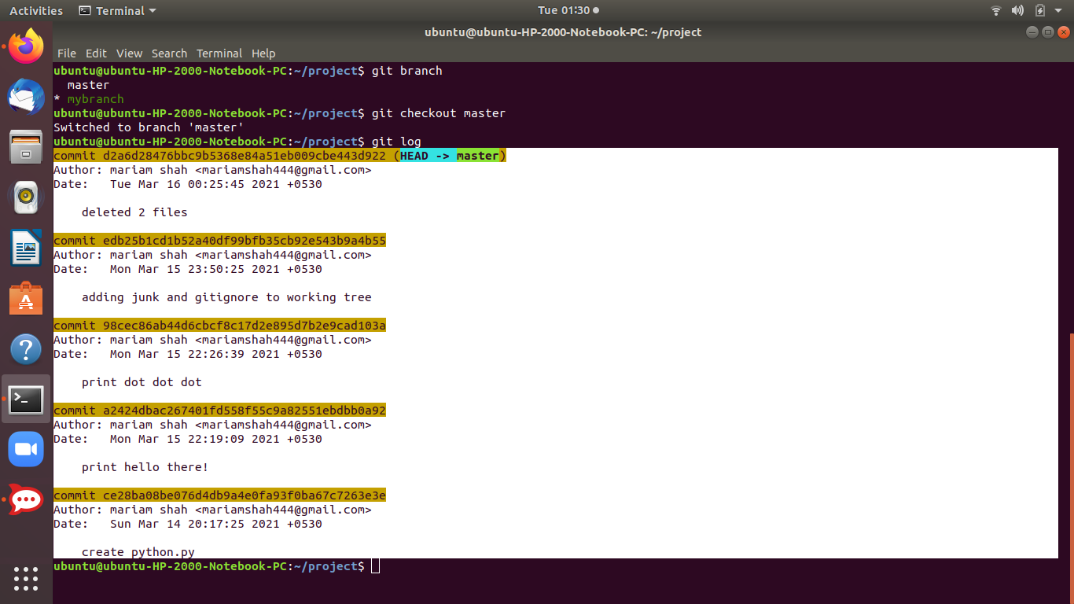

**Comparing Branches:**

## Compare two branches using *git diff* .In order to compare two branches easily, you have to use the “git diff” command and provide the branch names separated by dots.

$ git diff branch1..branch2

Using this command, Git will compare the tip of both branches (also called the HEAD) and display a “diff” recap that you can use to see modifications.

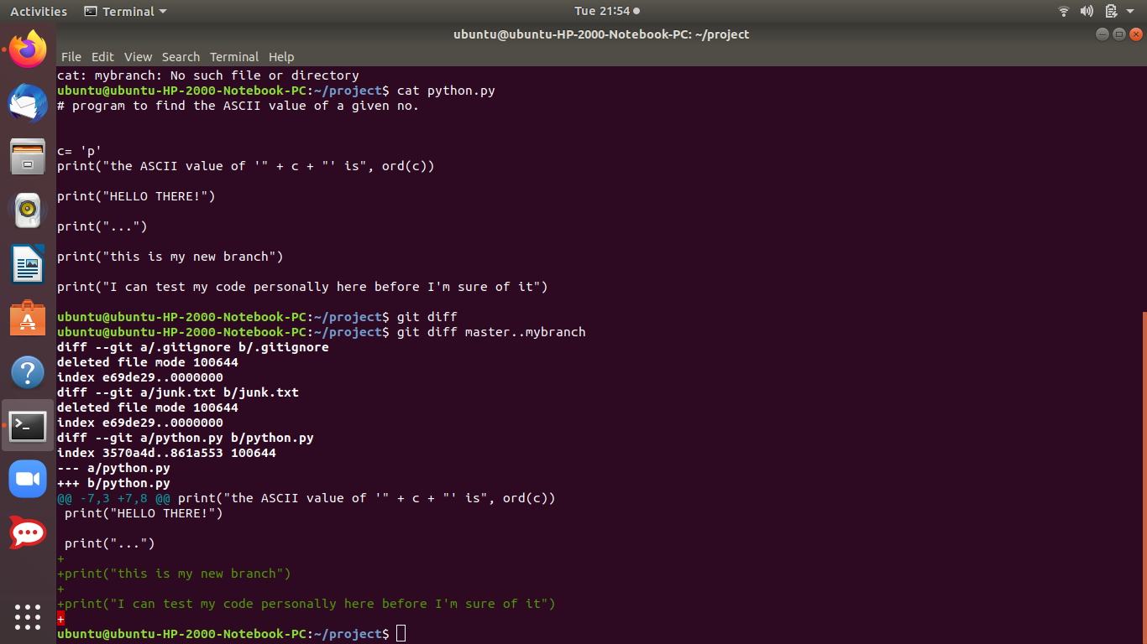

**3)Creating a new branch and checking out to the new branch simultaneously:** Both the things can be done simultaneously simply by using command:

$ git checkout -b <new branchname>

We simultaneously create a new branch “fancy” and switch to it too.

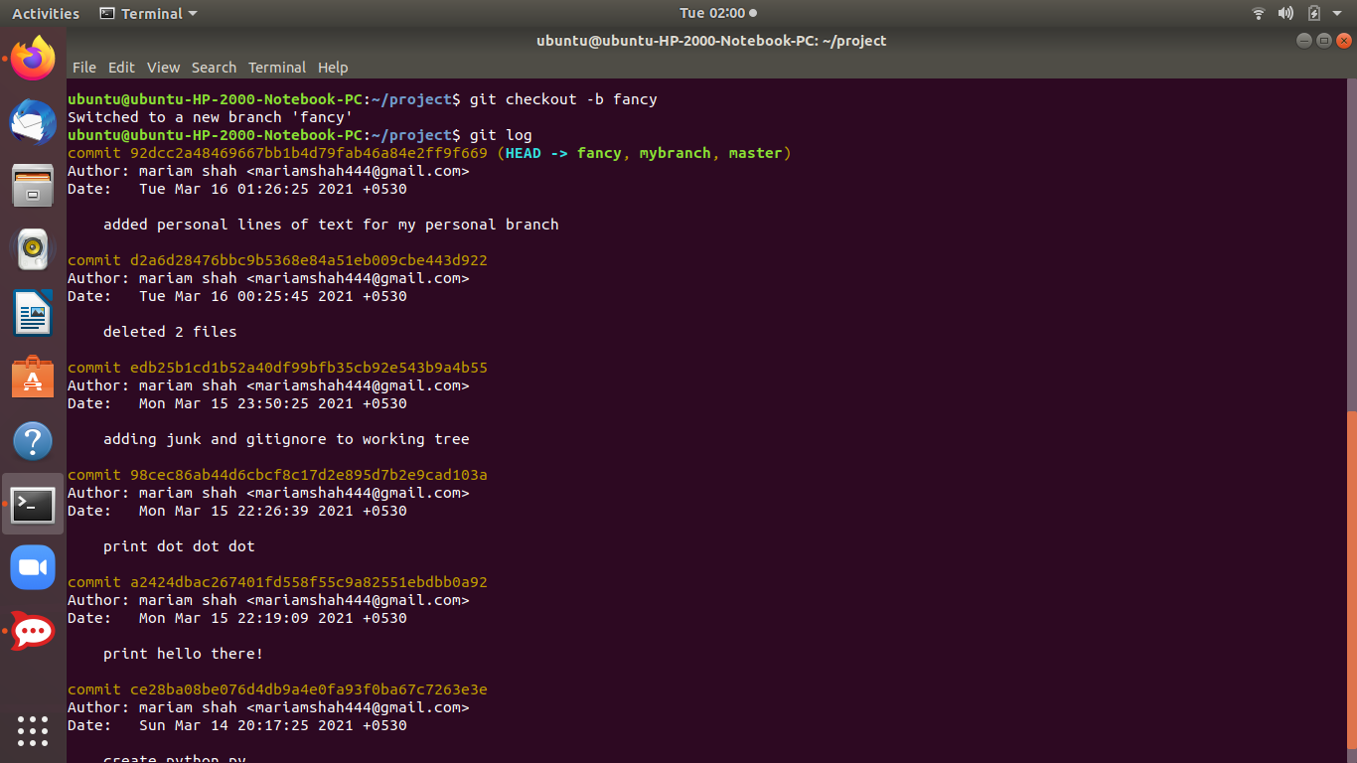

**4) Deleting a branch:**

To delete a branch, you can run the **git branch** command with the **-d** flag:

$ git branch -d <branch-name>

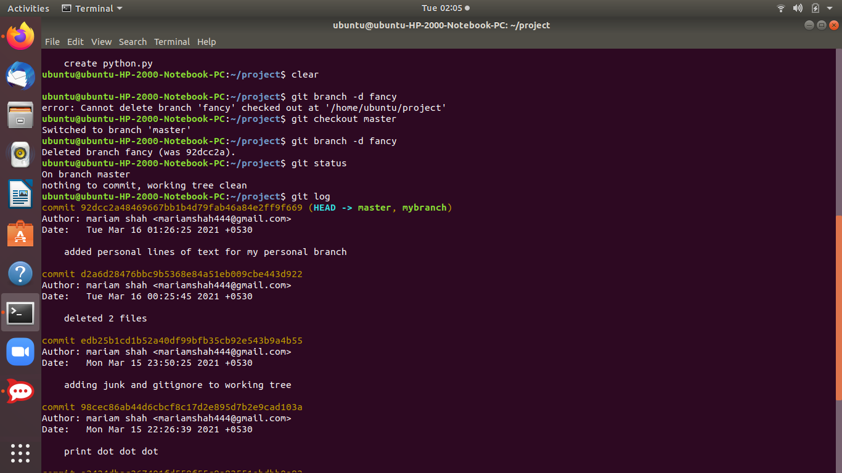

**4) Merging Branches:**

Now if we are sure of our new added changes and we want to merge it with our master branch.

**USE:**For example, after you fully implemented and tested a new feature in your code, you would want to merge those changes to the stable branch of your project (which is usually the default **master** branch).

To merge the changes from a different branch into your current branch, you can use this command:

$ git merge <branch-name>

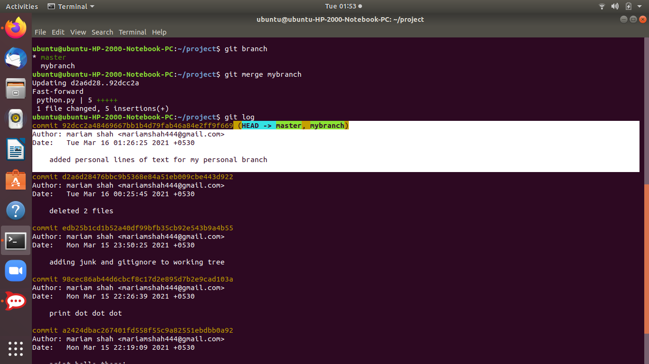

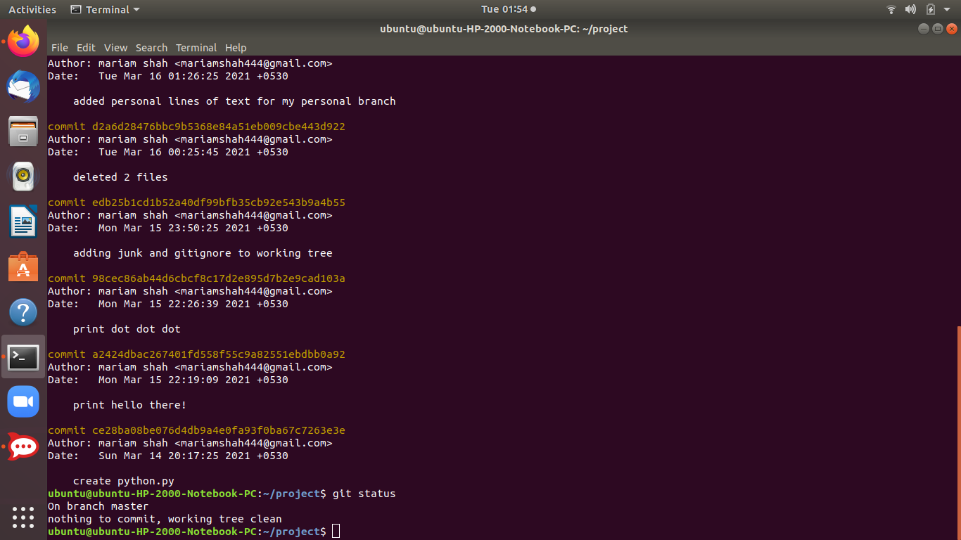

*We’d see now that all the changes have been added and merged to the master branch,after we merge.*

* ***This would definitely make sense once we work on a real-world project***

**$ git log --all --decorate --oneline --graph :**This command shows us a nice label to commit graphs.Also tells us if the master branch is checked out.

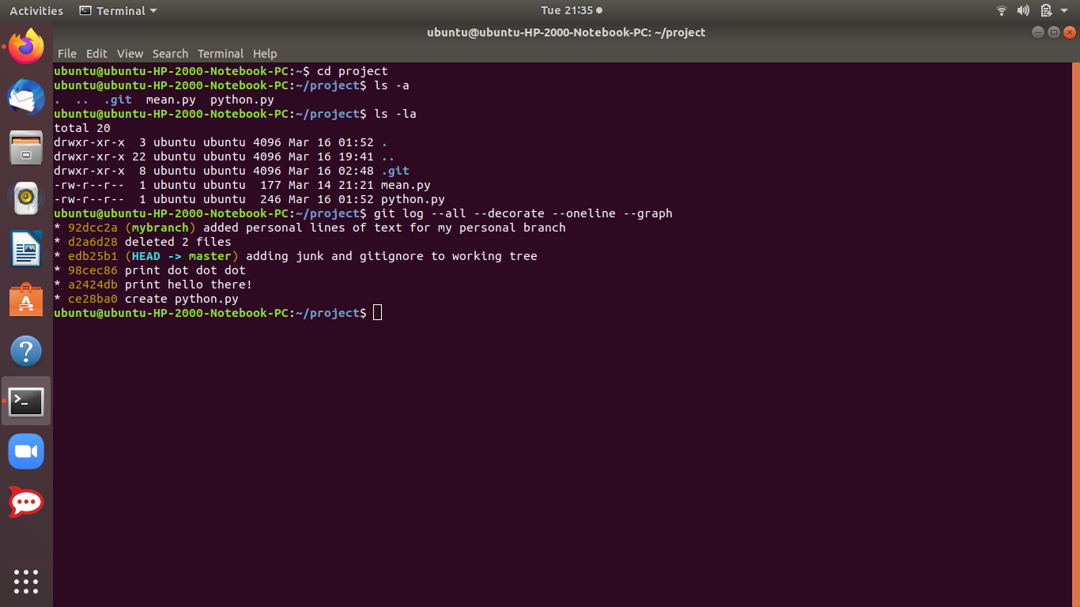

**Resolving Merge Conflicts:**

If two people changed the same lines in that same file, or if one person decided to delete it while the other person decided to modify it, Git simply cannot know what is correct. Git will then mark the file as having a **conflict -** which you'll have to solve before you can continue your work.

* **"git merge --abort"** command :
* **"git reset --hard”** command: to rollback undo the merge by using reset

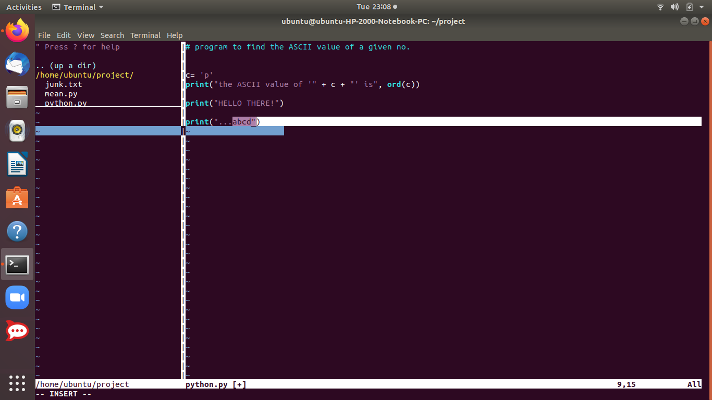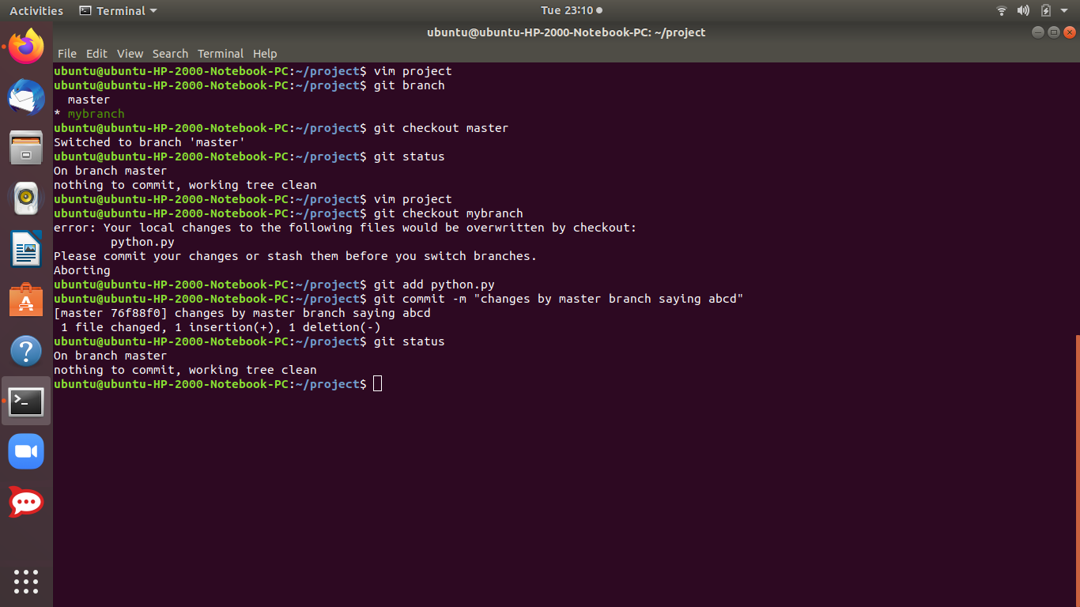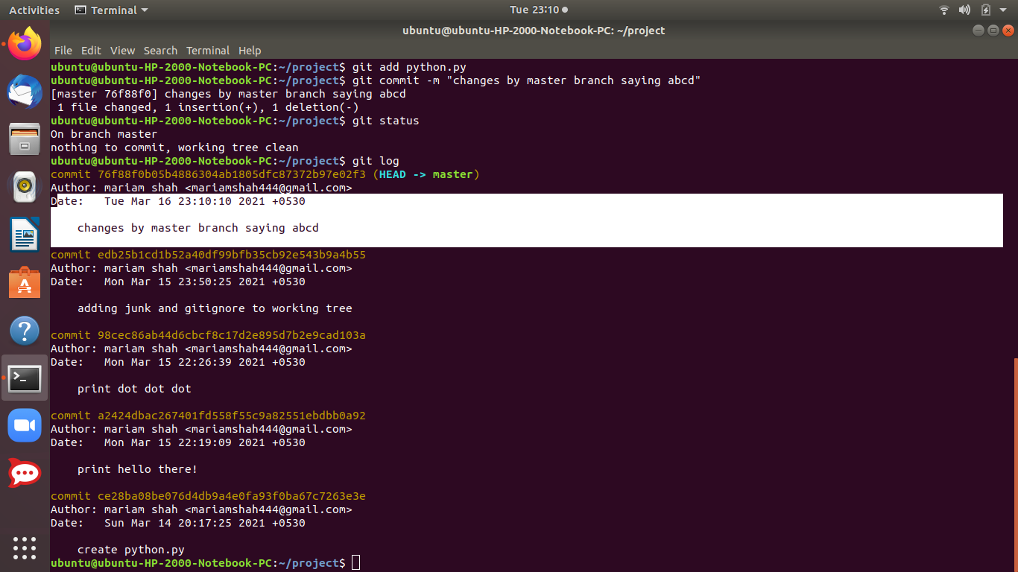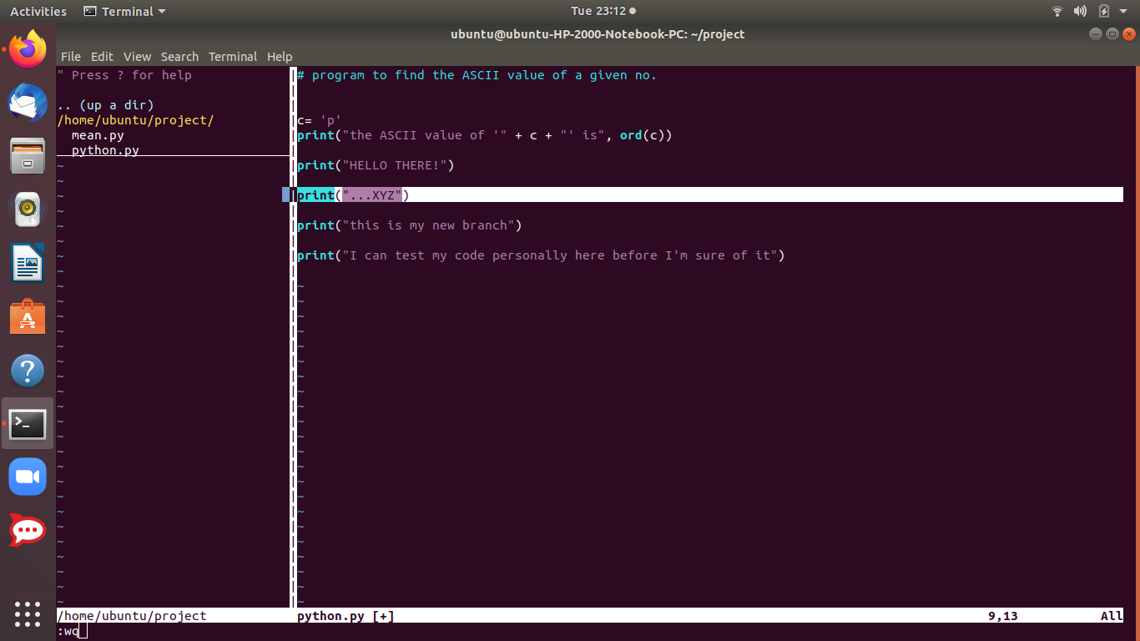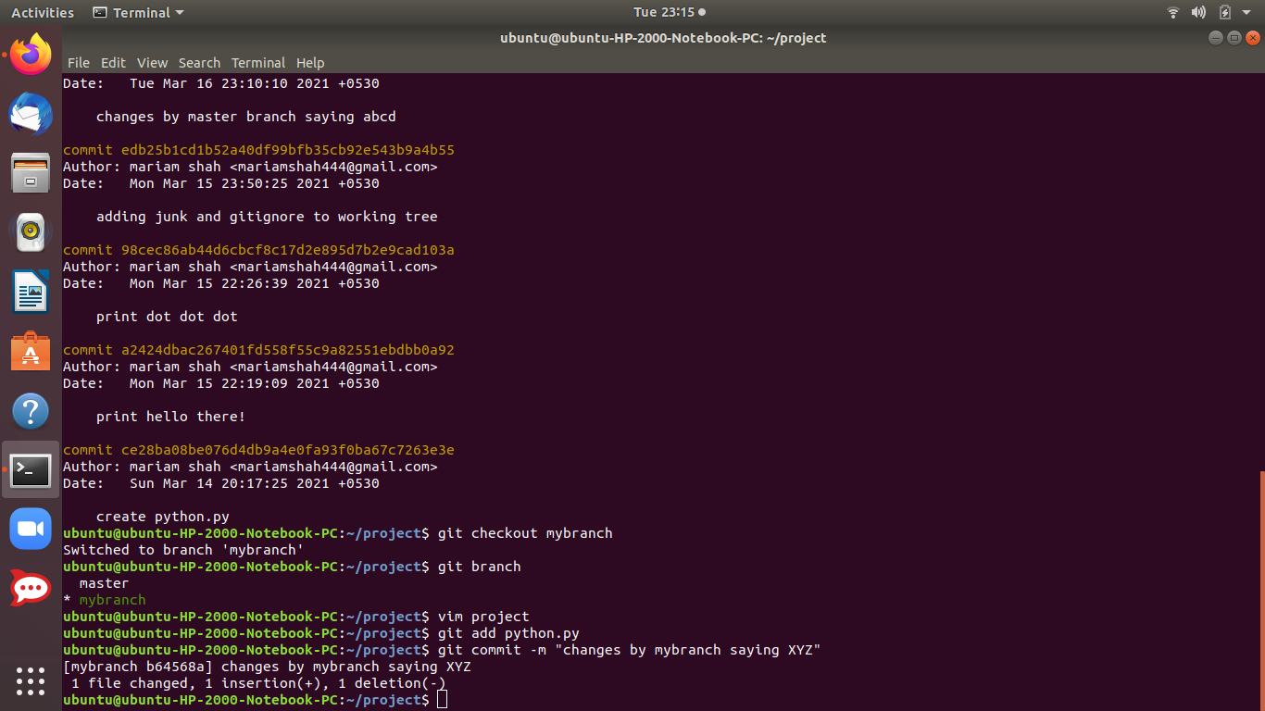

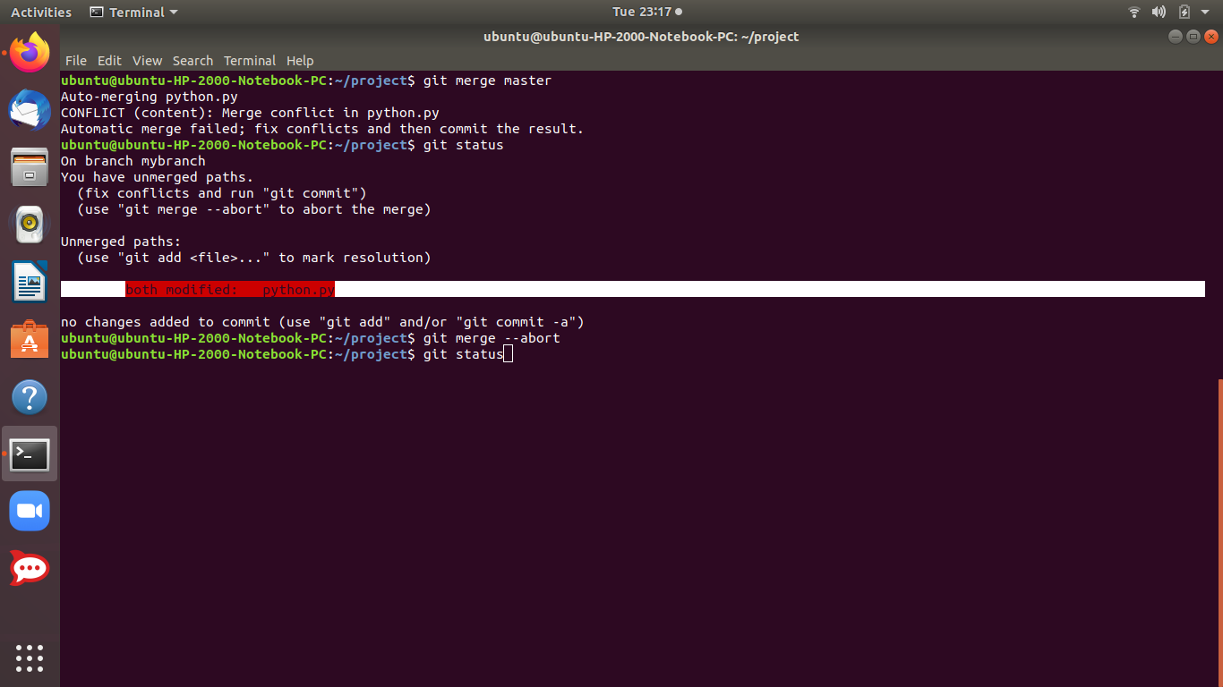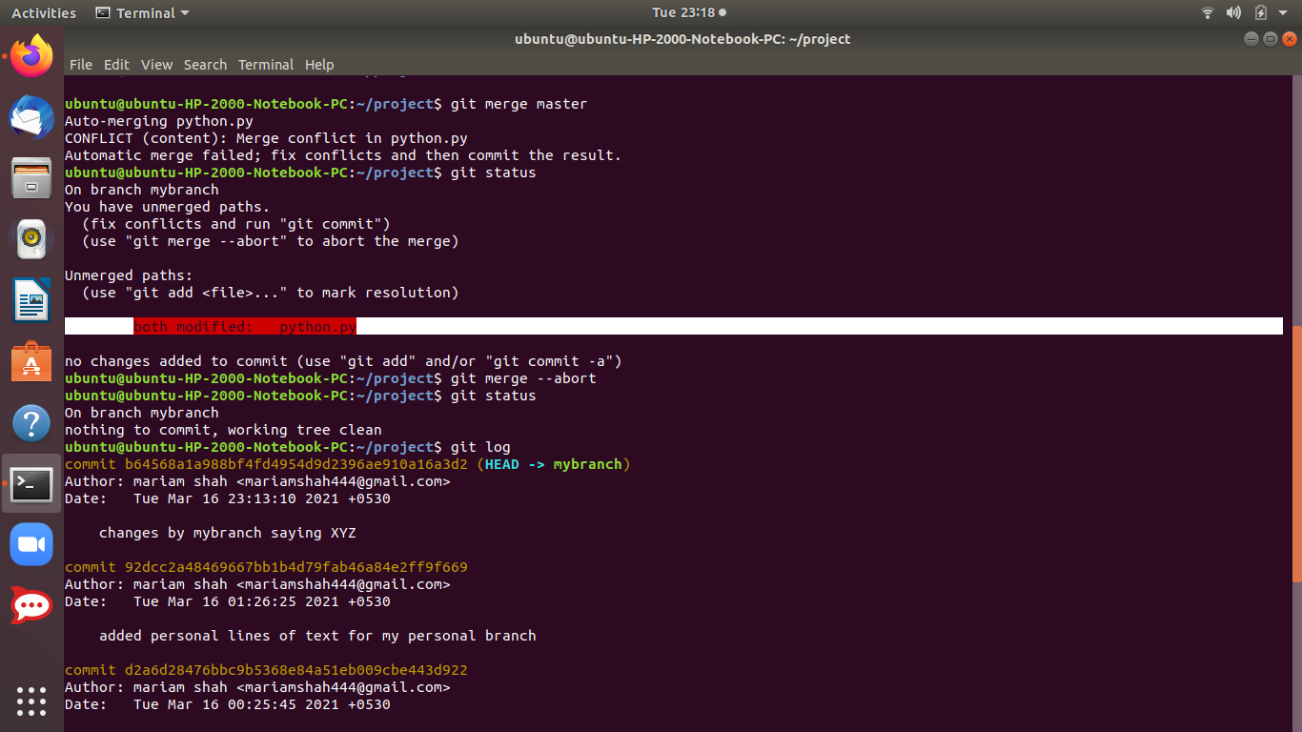

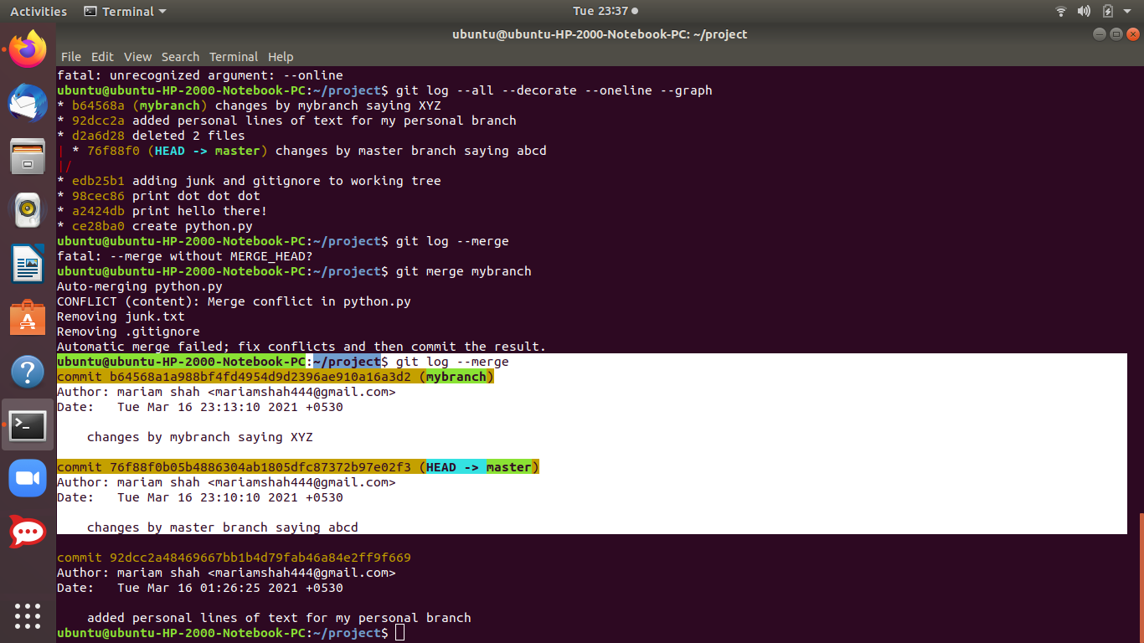

This way changes are preserved on different branches but recent merge is aborted by using either of the 2 commands.

**Getting started with Git-Hub**

# **1. What is GitHub?**

GitHub is a hosting platform for Git repositories. You can use Git on its own without Github (and other similar platforms), but it's difficult to collaborate or share your code with. others.

* **Git is the version control system, the tool that tracks changes to our files over time**
* **Github is a hosting service for projects that use Git.**

Git is used to store projects inside *repositories* and track the complete history of all changes to the project code. Using GitHub, we can upload a local project repository to a remote cloud-based GitHub repository. We can also interact with public repositories published by other developers.

# **2. Getting started with GitHub**

* GitHub allows developers to access a **remote** central repository hosted on the internet.
* A developer can clone(basically download) the hosted remote repository to their computer and work on a local version of the project.
* They can work on the code or develop new features on their local computer and whenever they're ready.
* those changes can be pushed to the remote repository hosted on GitHub, where other developers or team members can download it to their computer and stay synchronized with the project development.

**Basic steps to start using Git-Hub:**

1. **Registering with a github account.**Go to github and create an account .
2. **Using github:**

**Common Workflow:**

Using github, we can upload a local project to a remote coud based GitHub repository.We can also work with public repositories published by others.

* Users can give ratings
* Collaborate and communicate

1. **Pushing an existing repository:**

* Add /commit your code locally
* Go to Github and make a new repository
* Connect your local repository to the github repository(add a remote)
* Push your code to github using the ew remote

**Connect to a local repository:**

For this we need to setup something called a remote.Then we push the code using the remote.

**Adding a Remote:**

We can add a remote by using the following commands:

$ git remote add origin https://github.com/<your-username>/<your-repo-name>.git

The **git remote add origin** command will associate our local repository with the remote GitHub repository that we just created. We're essentially telling your Git repo that we have a URL we want it to know about, and we give it the name "origin". You do not have to name the remote "origin" but it is standard if you only have a single remote.

$ git remote -v : will list all the remotes if the repository as one

**Pushing the code:**The git push command will then push our local Git repository code to the remote GitHub repository (if you chose a public repository, this will publish your code on the internet - via GitHub).

$ git push -u origin master

When you run the **git push** command you will be prompted to enter your GitHub username and password, to log in to your GitHub account from the terminal.

After the repository was pushed, you can navigate back to your GitHub account page or the repository link and refresh it: <https://github.com/><your-username>/<your-repo-name>

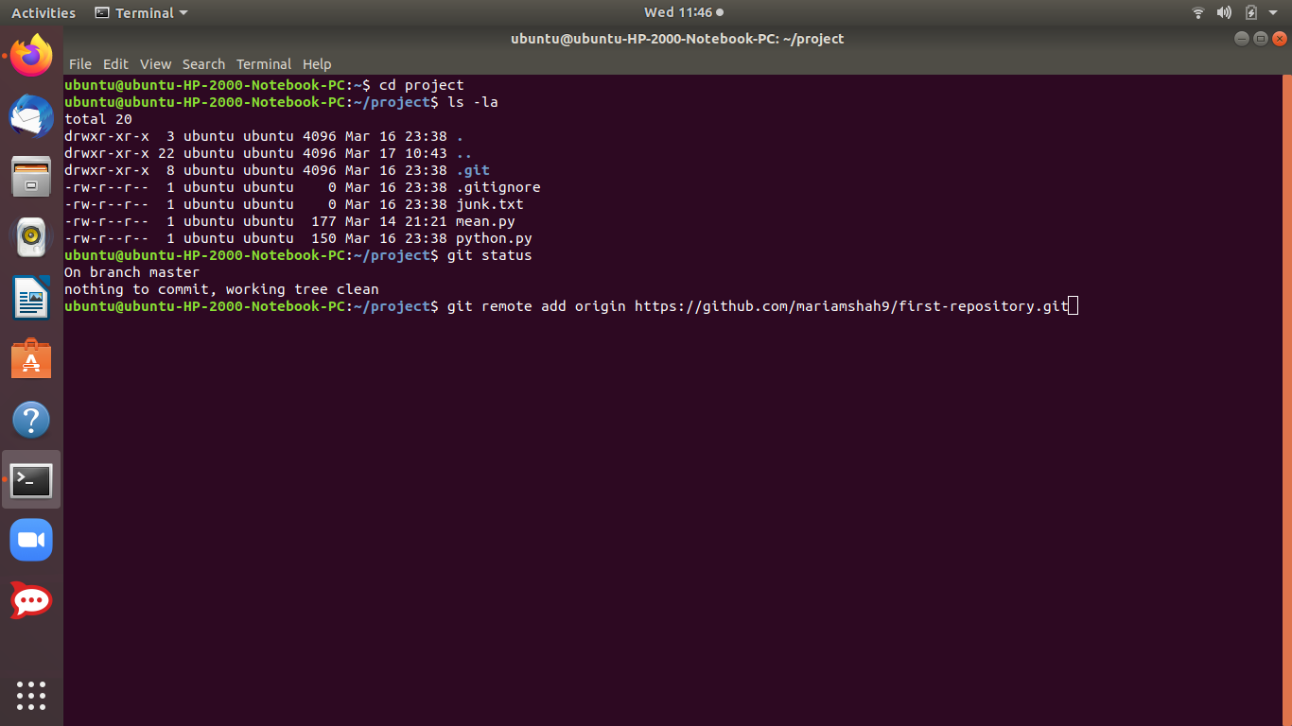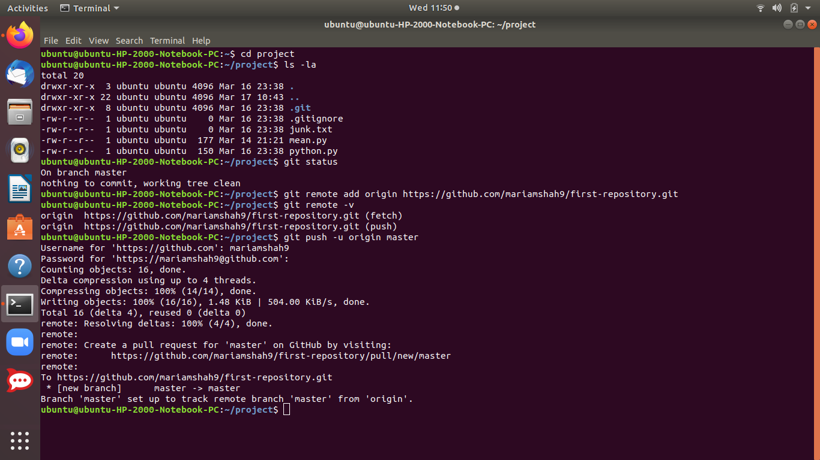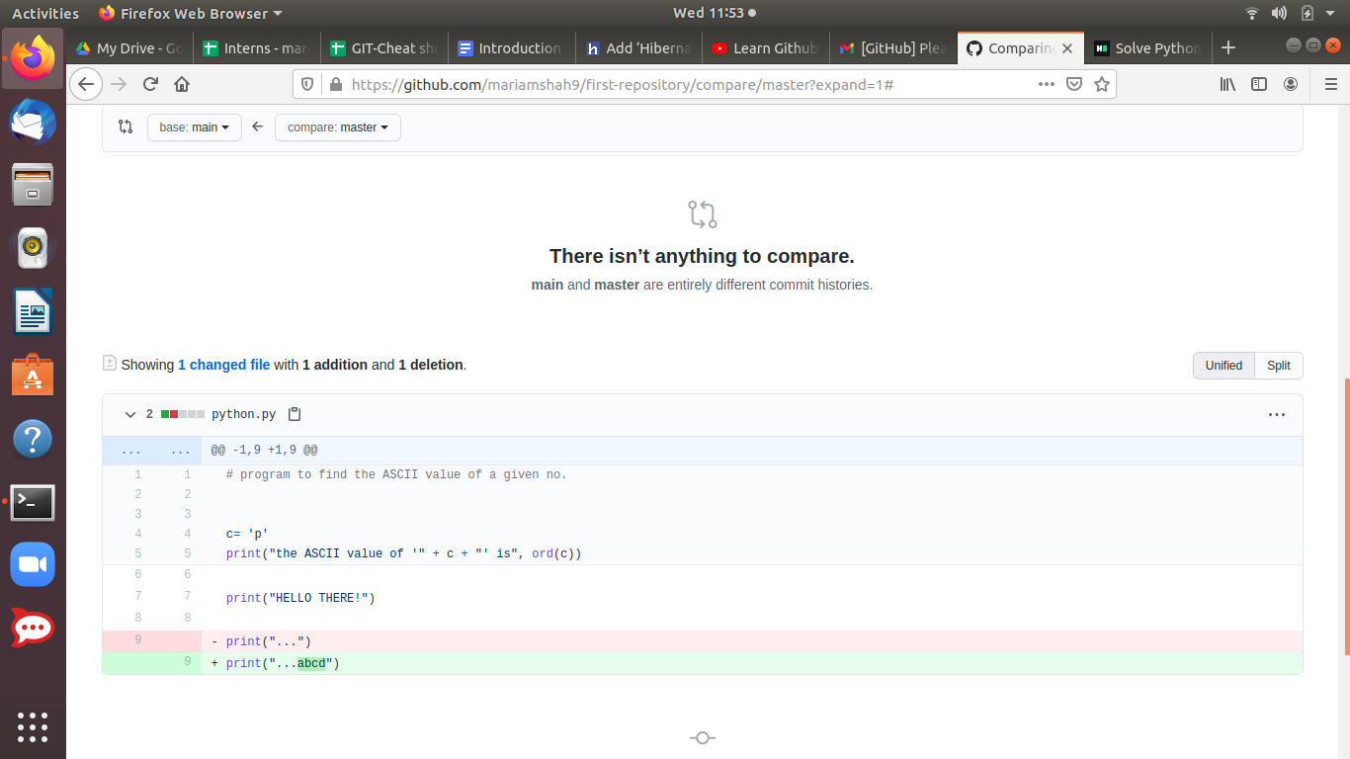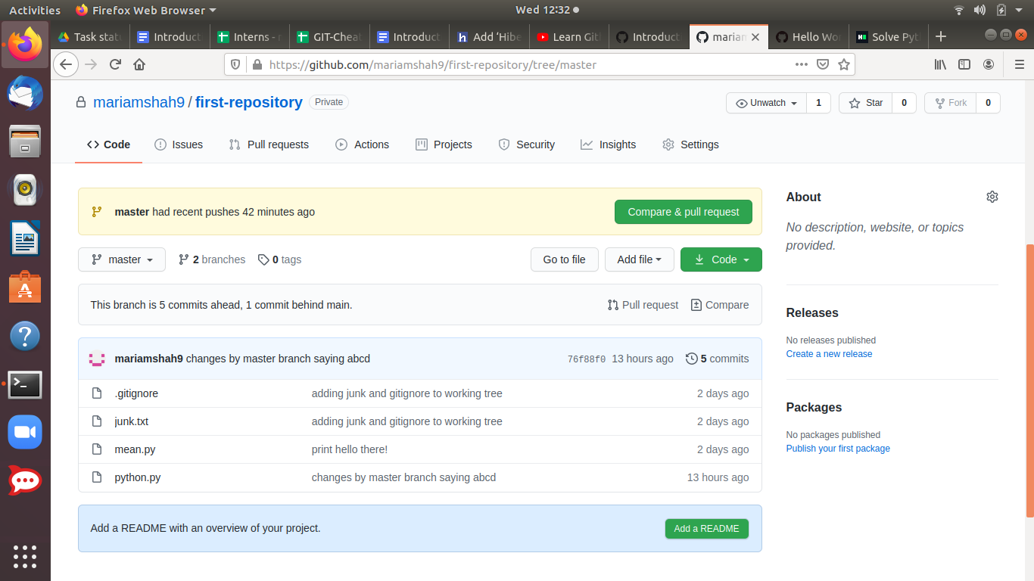

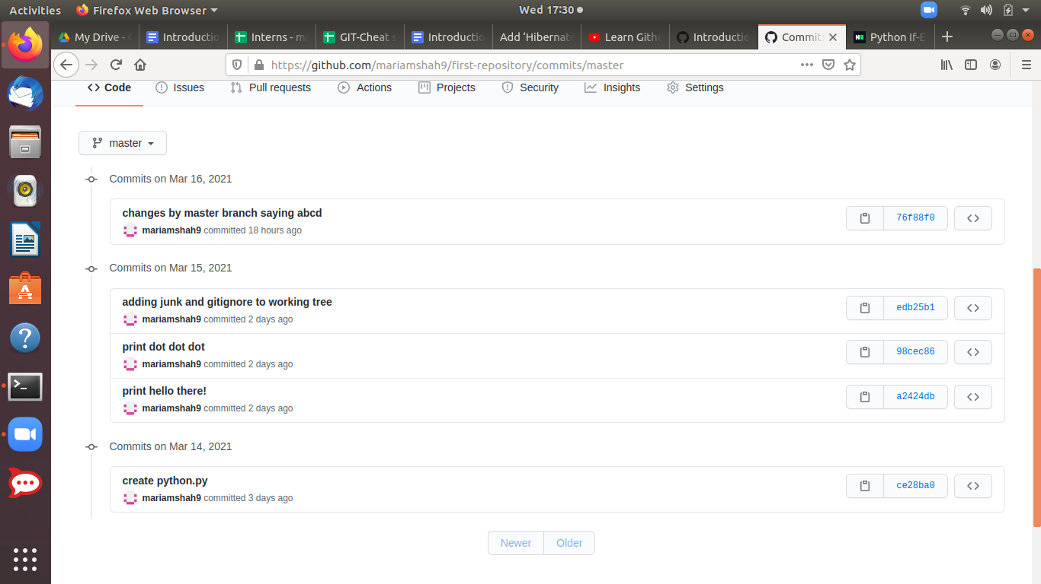

The above screenshot shows us the commits and their history which were done on the local machine.

**Making changes to the git repository:**

**1) CHANGES MADE IN LOCAL REPOSITORY:** Now, any changes that we make to our local project files won't automatically affect the remote GitHub repository, until we **push** those changes again, to update it.

After we bring the changes and commit them on our local repository ,they won't be reflected into our remote repository until we push back those changes with the push command:

git push origin master

After that, when you navigate back to your remote repository page on [github.com](http://github.com), you should see the updated code, and one more **commit** in the list.

I brought some simple print line changes through vim editor in python.py file on my local repository and committed it. But those changes are not reflected in the remote repository until we push them using the push command.

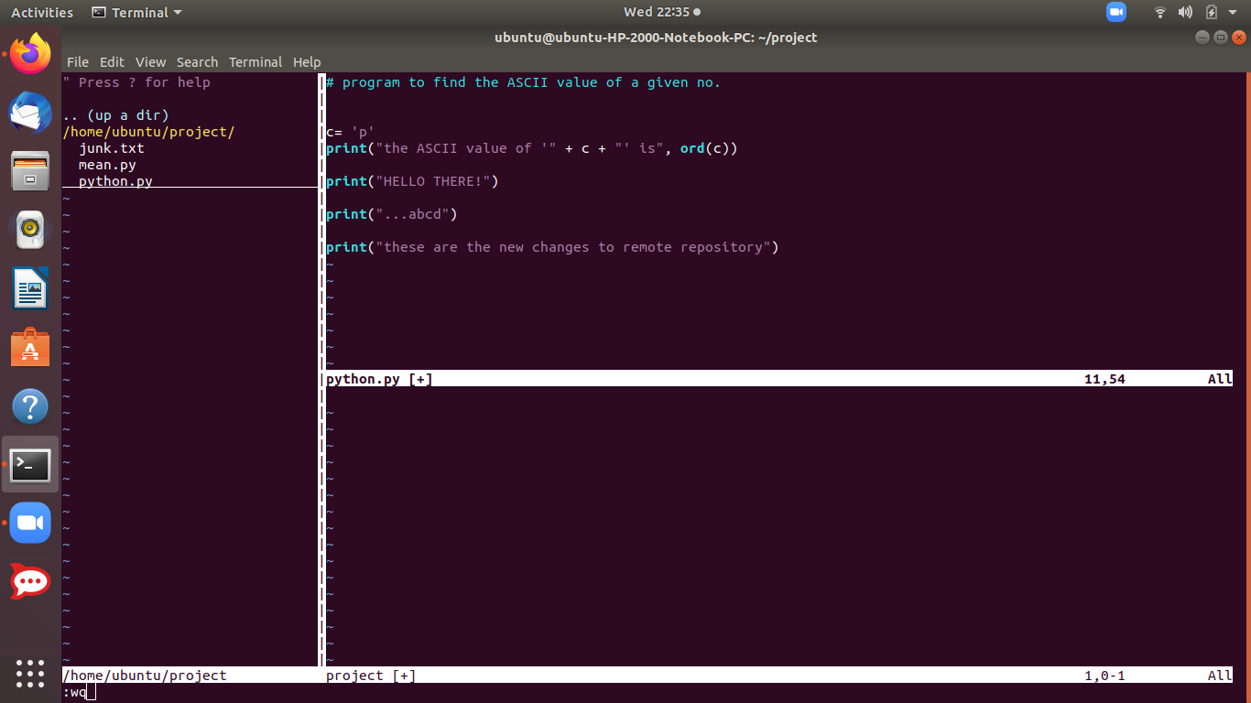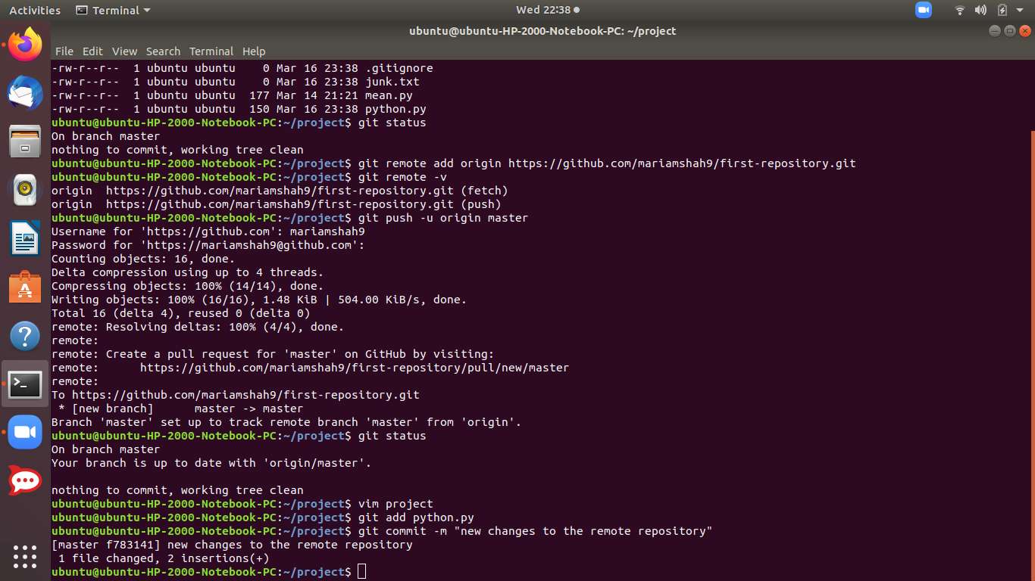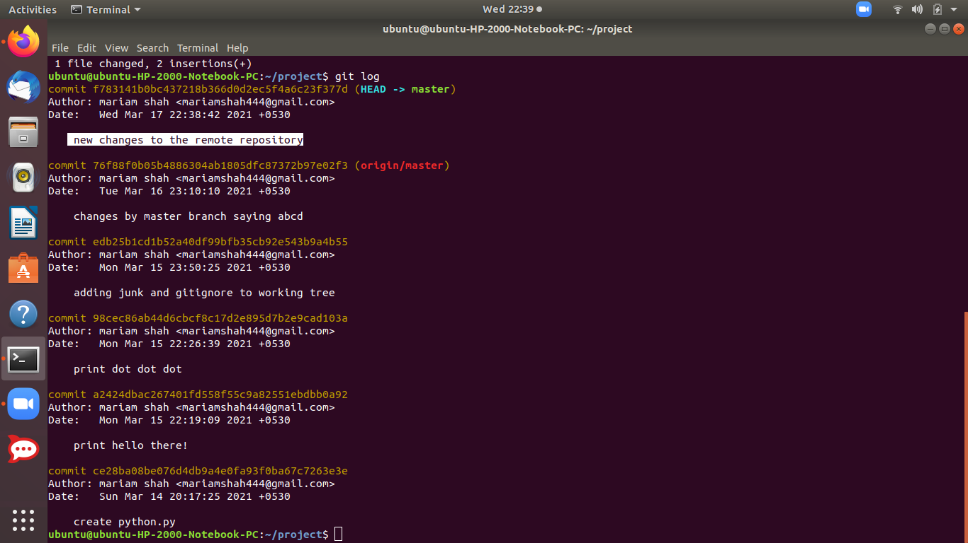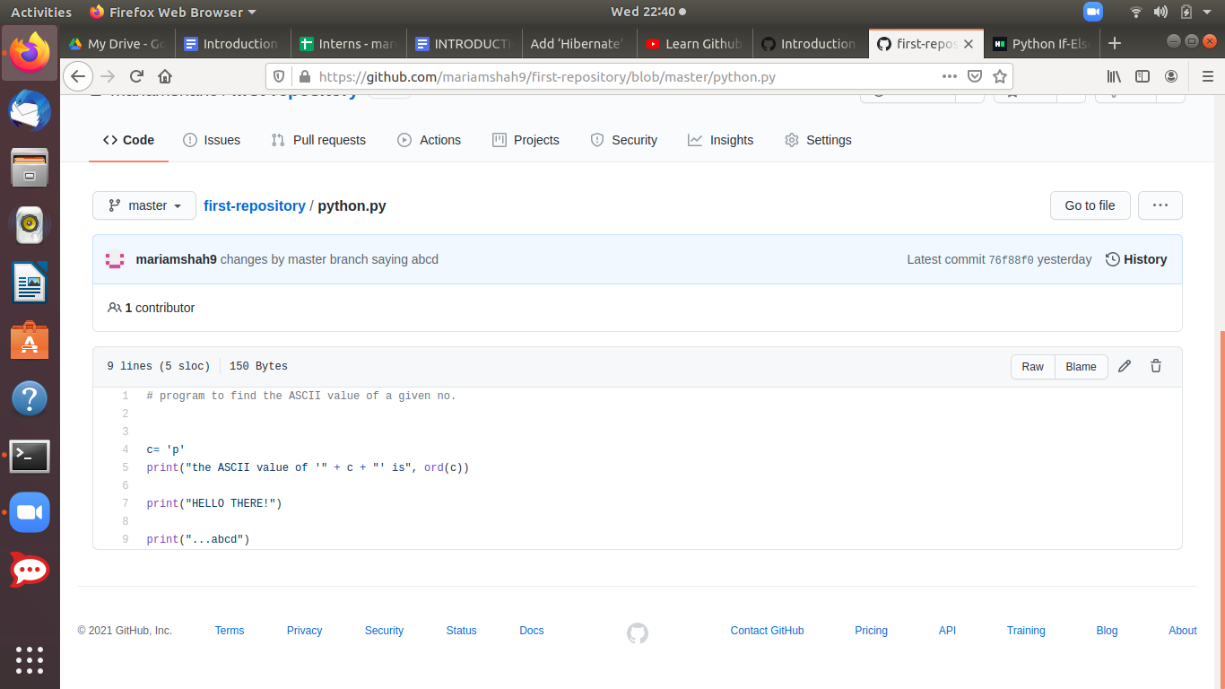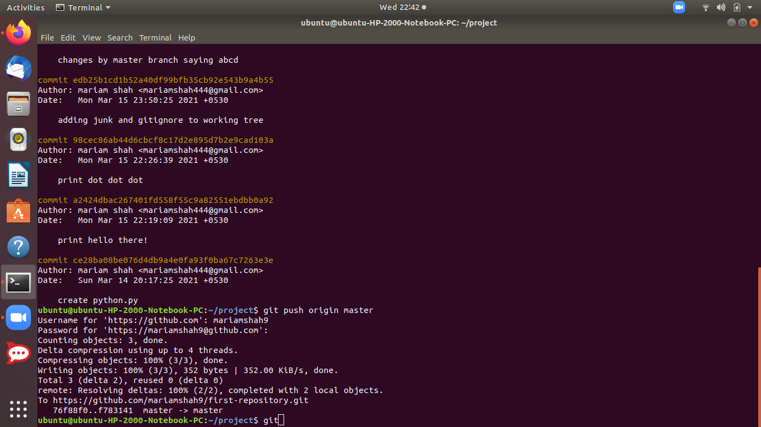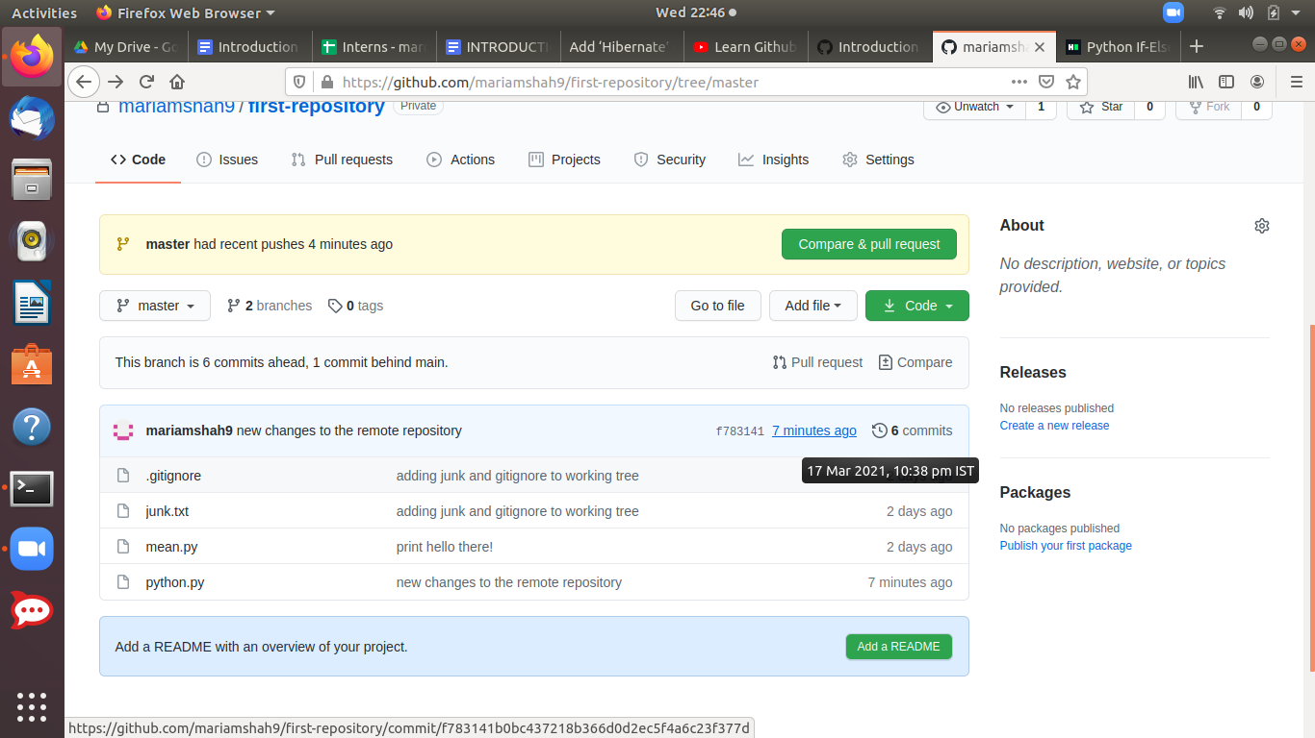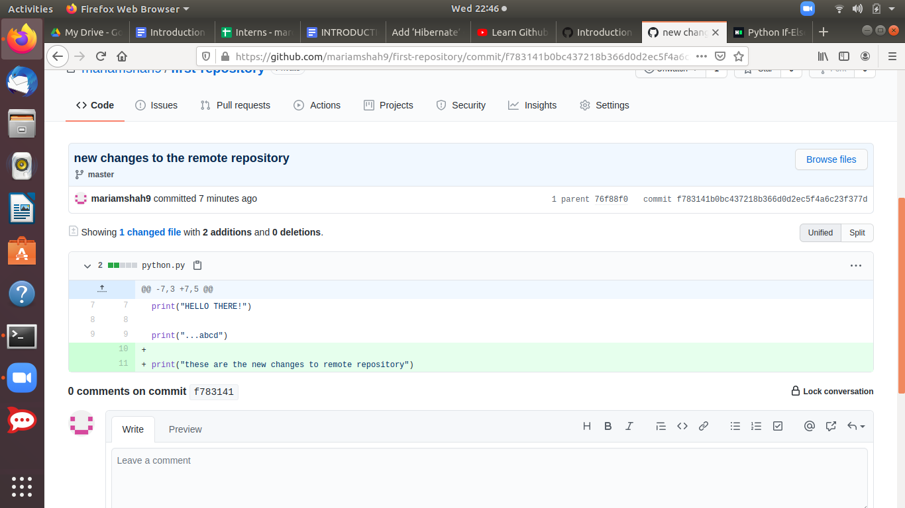

***Above 2 screenshots:*** *After we push the changes to the remote repository, when we refresh the page, we see changes are as well reflected into our remote repository.We cn check the commit history as well as the new lines of code added in github repo. as well.*

2)**CHANGES MADE IN REMOTE REPOSITORY:** If we are making changes in the remote repository, again it wont be reflected in our local repository and running the git remote show origin, which gives more info to us about the remote, will show us local out of date which means our local repository needs to be updated by the latest commits happening in our remote repository.

So, we pull the latest commits from the remote repo using the pull command:

$ git pull

I’m going to add a readme.md file to the master branch from the remote repository. And see what happens to local repo. And then try to pull the changes to local repo.

